**Additional Queries**

Comprehensive study

/* Our comprehensive view encompasses the analysis of 13 tables, revealing intricate interrelationships among variables including age, race, gender, group, mean arterial pressure (MAP), eye damage, cholesterol, fasting glucose, and dementia tests. Through a holistic examination of these variables, we uncover valuable insights into their interconnected nature and the influence they exert on one another. This study provides a comprehensive understanding of the dataset, illuminating the complex relations between tables and their broader implications.*/

CREATE OR REPLACE VIEW patient_info AS

SELECT

P."Patient_ID",

CONCAT(P."Firstname", ' ', P."Lastname") AS "Full_Name",

G."Gender",

P."Age",

R."Race",

LV."Lab_names",

CASE

WHEN GR."Group" = 'DM' THEN 'Diabetic'

ELSE 'Control'

END AS "Group",

CASE

WHEN (((BP."24Hr_Day_SBP" + 2 * BP."24Hr_Day_DBP") / 3) < 70) OR (((BP."24Hr_Night_SBP" + 2 * BP."24Hr_Night_DBP") / 3) < 70) THEN 'Low'

WHEN (((BP."24Hr_Day_SBP" + 2 * BP."24Hr_Day_DBP") / 3) >= 70 AND ((BP."24Hr_Day_SBP" + 2 * BP."24Hr_Day_DBP") / 3) <= 100) OR (((BP."24Hr_Night_SBP" + 2 * BP."24Hr_Night_DBP") / 3) >= 70 AND ((BP."24Hr_Night_SBP" + 2 * BP."24Hr_Night_DBP") / 3) <= 100) THEN 'Normal'

ELSE 'High'

END AS "Map",

CASE

WHEN O."Macular_Edema" <> 0 THEN 'Macular_Edema'

WHEN O."Diabetic_Retinopathy" <> 0 THEN 'Diabetic_Retinopathy'

ELSE 'No'

END AS "Eye_Damage",

CASE

WHEN L."Fasting_Cholestrol" < 150 THEN 'Normal'

ELSE 'High'

END AS "Cholesterol",

CASE

WHEN LT."Fasting_Glucose" <= 70 THEN 'Hypoglycemia'

WHEN LT."Fasting_Glucose" > 70 AND LT."Fasting_Glucose" <= 100 THEN 'Normal'

WHEN LT."Fasting_Glucose" > 100 AND LT."Fasting_Glucose" <= 120 THEN 'Pre_Diabetic'

ELSE 'Diabetic'

END AS "Insulin",

CONCAT_WS(',',

CASE WHEN MC."IADL" <= 14 THEN 'IADL' END,

CASE WHEN MC."MMSE" <= 23 THEN 'MMSE' END,

CASE WHEN MC."GDS" >= 15 THEN 'GDS' END,

CASE WHEN VMC."RCFT_IR" <= 71 THEN 'RCFT_IR' END,

CASE WHEN VMC."TM" >= 42 THEN 'TM' END,

CASE WHEN VMC."Clock" <= 2 THEN 'Clock' END,

CASE WHEN VC."DS" < 13 THEN 'DS' END,

CASE WHEN VC."HVLT" < 19 THEN 'HVLT' END,

CASE WHEN VC."VF" < 42 THEN 'VF' END,

CASE WHEN VC."WTAR" <= 20 THEN 'WTAR' END

) AS "Dementia",

CASE

WHEN U."Creatinine" IS NOT NULL AND U."Albumin" IS NOT NULL THEN

CASE

WHEN G."Gender" = 'Male' AND U."Creatinine" BETWEEN 65.4 AND 119.3 AND U."Albumin" BETWEEN 3.4 AND 5.4 THEN 'Normal'

WHEN G."Gender" = 'Female' AND U."Creatinine" BETWEEN 52.2 AND 91.9 AND U."Albumin" BETWEEN 3.4 AND 5.4 THEN 'Normal'

WHEN G."Gender" = 'Male' AND (U."Creatinine" < 65.4 OR U."Creatinine" > 119.3) THEN 'A.Creat'

WHEN G."Gender" = 'Female' AND (U."Creatinine" < 52.2 OR U."Creatinine" > 91.9) THEN 'A.Creat'

WHEN U."Albumin" < 3.4 OR U."Albumin" > 5.4 THEN 'A.Alb'

ELSE 'A.Creat, A.Alb'

END

END AS "Lipid"

FROM

public."Patients" P

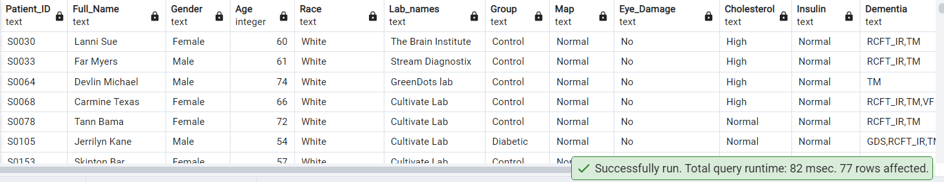

1) Find the list of all the patients with full name whose RPE start and RPE end

shows Moderate intensity.

SELECT P."Patient_ID",P."Firstname" || ' ' || P."Lastname" AS "Fullname",W."Gait_RPE_Start ",W."Gait_RPE_End "

FROM public."Patients" P

JOIN public."Walking_Test" W ON W."WalkTest_ID" = P."WalkTest_ID"

WHERE W."Gait_RPE_Start " BETWEEN 4 AND 6

AND W."Gait_RPE_End " BETWEEN 4 AND 6

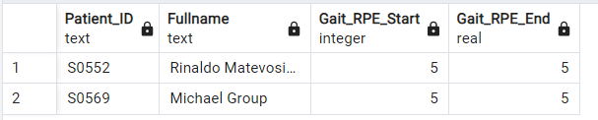



2) Show the percentage of MALE:FEMALE

SELECT

ROUND(COUNT(CASE WHEN G."Gender" = 'Male' THEN 1 END)::decimal / COUNT(*) * 100, 2) AS "Male Percentage",

ROUND(COUNT(CASE WHEN G."Gender" = 'Female' THEN 1 END)::decimal / COUNT(*) * 100, 2) AS "Female Percentage"

FROM public."Patients" P

JOIN public."Gender" G ON P."Gender_ID" = G."Gender_ID";

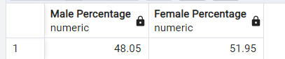



3) patient distribution across fasting_glucose

SELECT

ROUND(COUNT(CASE WHEN LT."Fasting_Glucose" < 70 THEN 1 END) * 100.0 / COUNT(*), 2) AS "Hypoglycemia (%)",

ROUND(COUNT(CASE WHEN LT."Fasting_Glucose" >= 70 AND LT."Fasting_Glucose" <= 100 THEN 1 END) * 100.0 / COUNT(*), 2) AS "Normal (%)",

ROUND(COUNT(CASE WHEN LT."Fasting_Glucose" > 100 AND LT."Fasting_Glucose" <= 120 THEN 1 END) * 100.0 / COUNT(*), 2) AS "Prediabetic (%)",

ROUND(COUNT(CASE WHEN LT."Fasting_Glucose" > 120 THEN 1 END) * 100.0 / COUNT(*), 2) AS "Diabetic (%)"

FROM public."Patients" P

JOIN public."Lab_Test" LT ON LT."Patient_ID" = P."Patient_ID"

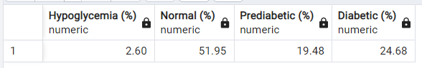



4)Percentage of male and female who have diabetics

SELECT

ROUND(COUNT(CASE WHEN G."Gender" = 'Male' AND LT."Fasting_Glucose" > 120 THEN 1 END) * 100.0 / COUNT(CASE WHEN G."Gender" = 'Male' THEN 1 END), 2) AS "Male Diabetics (%)",

ROUND(COUNT(CASE WHEN G."Gender" = 'Female' AND LT."Fasting_Glucose" > 120 THEN 1 END) * 100.0 / COUNT(CASE WHEN G."Gender" = 'Female' THEN 1 END), 2) AS "Female Diabetics (%)"

FROM public."Patients" P

JOIN public."Gender" G ON P."Gender_ID" = G."Gender_ID"

JOIN public."Lab_Test" LT ON LT."Patient_ID" = P."Patient_ID"

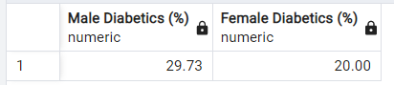



5) A study to check how many patients who have abnormal lipid profile have been diagnosed with diabetes.

WITH Diabetic_Patients AS (

SELECT LL."Patient_ID"

FROM public."Lipid_Lab_Test" LL

WHERE LL."Fasting_HDL" < 50 AND LL."Fasting_LDL" > 130 AND LL."Fasting_Triglyc" > 150

),

Sugar_Status AS (

SELECT LL."Patient_ID",

CASE

WHEN LT."Insulin" < 2.6 THEN 'Low Sugar'

WHEN LT."Insulin" > 24.9 THEN 'High Sugar'

ELSE 'Normal'

END AS "Sugar_Status"

FROM public."Lab_Test" LT

JOIN public."Lipid_Lab_Test" LL ON LT."Patient_ID" = LL."Patient_ID"

)

SELECT "Sugar_Status", COUNT(*) AS "Count",

ROUND(COUNT(*) * 100.0 / (SELECT COUNT(*) FROM public."Lipid_Lab_Test" ), 2) AS "Percentage"

FROM Sugar_Status

GROUP BY "Sugar_Status"

ORDER BY "Sugar_Status";

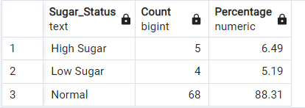



6) check how many in men and women are in risk for liver disorder by checking creatinine albumin ratio

SELECT G."Gender",COUNT(*) AS "Patient_Count"

FROM public."Patients" P

JOIN public."Link_Reference" LR ON P."Link_Reference_ID" = LR."Link_Reference_ID"

JOIN public."Urine_Test" U ON LR."Urine_ID" = U."Urine_ID"

JOIN public."Gender" G ON P."Gender_ID" = G."Gender_ID"

WHERE (G."Gender" = 'Male' AND U."Creatinine" / U."Albumin" > 17)

OR (G."Gender" = 'Female' AND U."Creatinine" / U."Albumin" > 25)

GROUP BY G."Gender";

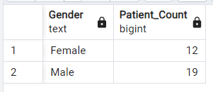



7) relation between sugar and dementia

SELECT

COUNT(*) AS "Diabetic_Patients",

COUNT(CASE WHEN VM."RCFT_IR" > 71 OR VM."TM" > 42 OR VM."Clock" <= 2 OR MC."GDS" >= 15 THEN 1 END) AS "Diabetic_Patients_With_Dementia",

ROUND((COUNT(CASE WHEN VM."RCFT_IR" > 71 OR VM."TM" > 42 OR VM."Clock" <= 2 OR MC."GDS" >= 15 THEN 1 END) * 100.0) / COUNT(*), 2) AS "Percentage"

FROM public."Lab_Test" LT

JOIN public."Link_Reference" LR ON LT."Lab_ID" = LR."Lab_ID"

JOIN public."Visual/Motor_Cog" VM ON LR."VM_ID" = VM."VM_ID"

JOIN public."Memory_Cognitive" MC ON LR."MC_ID" = MC."MC_ID"

WHERE LT."Fasting_Glucose" > 120;

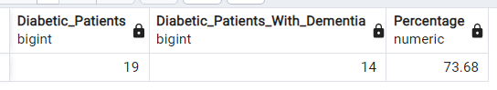



8) yearwise study of which age has diabetes.

SELECT

EXTRACT(YEAR FROM P."Visit_Date") AS "Year",

CONCAT((FLOOR(P."Age" / 10) * 10), '-', (FLOOR(P."Age" / 10) * 10 + 10)) AS "Age_Group",

COUNT(*) AS "Diabetic_Count"

FROM public."Lab_Test" LT

JOIN public."Patients" P ON LT."Patient_ID" = P."Patient_ID"

WHERE LT."Fasting_Glucose"> 120

GROUP BY "Year", "Age_Group"

ORDER BY "Year", "Age_Group";

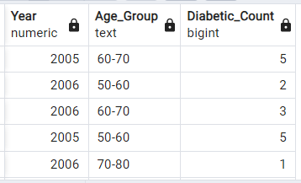



9)What is the distribution of diabetic patients based on their age groups and the corresponding years of their lab test visits, considering only those patients whose fasting glucose levels are above 120?

SELECT

EXTRACT(YEAR FROM P."Visit_Date") AS "Year",

CONCAT((FLOOR(P."Age" / 10) * 10), '-', (FLOOR(P."Age" / 10) * 10 + 10)) AS "Age_Group",

COUNT(*) AS "Diabetic_Count"

FROM public."Lab_Test" LT

JOIN public."Patients" P ON LT."Patient_ID" = P."Patient_ID"

WHERE LT."Fasting_Glucose"> 120

GROUP BY "Year", "Age_Group"

ORDER BY "Year", "Age_Group";

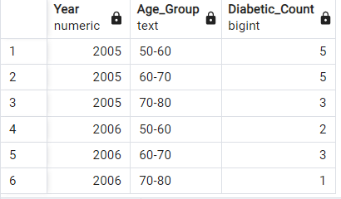



10)Show the First_Visit_Date to Last_Visit_Date

SELECT

MIN("Visit_Date") AS "First_Visit_Date",

MAX("Visit_Date") AS "Last_Visit_Date"

FROM public."Patients";

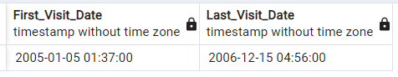



11) patient distribution across fasting_glucose

SELECT

'Hypoglycemia' AS Condition,

ROUND(COUNT(CASE WHEN LT."Fasting_Glucose" < 70 THEN 1 END) * 100.0 / COUNT(*), 2) AS Percentage

FROM public."Patients" P

JOIN public."Lab_Test" LT ON LT."Patient_ID" = P."Patient_ID"

UNION

SELECT

'Normal' AS Condition,

ROUND(COUNT(CASE WHEN LT."Fasting_Glucose" >= 70 AND LT."Fasting_Glucose" <= 100 THEN 1 END) * 100.0 / COUNT(*), 2) AS Percentage

FROM public."Patients" P

JOIN public."Lab_Test" LT ON LT."Patient_ID" = P."Patient_ID"

UNION

SELECT

'Prediabetic' AS Condition,

ROUND(COUNT(CASE WHEN LT."Fasting_Glucose" > 100 AND LT."Fasting_Glucose" <= 120 THEN 1 END) * 100.0 / COUNT(*), 2) AS Percentage

FROM public."Patients" P

JOIN public."Lab_Test" LT ON LT."Patient_ID" = P."Patient_ID"

UNION

SELECT

'Diabetic' AS Condition,

ROUND(COUNT(CASE WHEN LT."Fasting_Glucose" > 120 THEN 1 END) * 100.0 / COUNT(*), 2) AS Percentage

FROM public."Patients" P

JOIN public."Lab_Test" LT ON LT."Patient_ID" = P."Patient_ID";

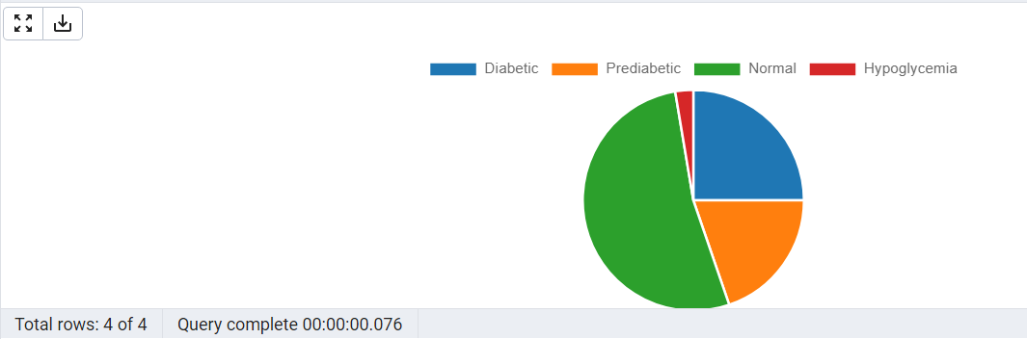

12) What are the dominant age groups among diabetic patients for each year, considering only those patients whose fasting glucose levels are above 120?

SELECT "Year", "Age_Group", "Diabetic_Count"

FROM (

SELECT

EXTRACT(YEAR FROM P."Visit_Date") AS "Year",

CONCAT((FLOOR(P."Age" / 10) * 10), '-', (FLOOR(P."Age" / 10) * 10 + 10)) AS "Age_Group",

COUNT(*) AS "Diabetic_Count",

ROW_NUMBER() OVER (PARTITION BY EXTRACT(YEAR FROM P."Visit_Date") ORDER BY COUNT(*) DESC) AS rn

FROM public."Lab_Test" LT

JOIN public."Patients" P ON LT."Patient_ID" = P."Patient_ID"

WHERE LT."Fasting_Glucose" > 120

GROUP BY "Year", "Age_Group"

) AS subquery

WHERE rn = 1

ORDER BY "Year";

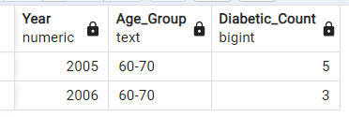



13. Get the average blood pressure readings for male and female patients

SELECT g."Gender", AVG(bp."24Hr_Day_SBP"),AVG(bp."24Hr_Day_DBP"),AVG("24Hr_Night_SBP"),AVG("24Hr_Night_DBP")

FROM public."Patients" p, public."Gender" g, public."Blood_Pressure" bp

WHERE p."Patient_ID"=bp."Patient_ID"

AND p."Gender_ID"=g."Gender_ID"

GROUP BY g."Gender";

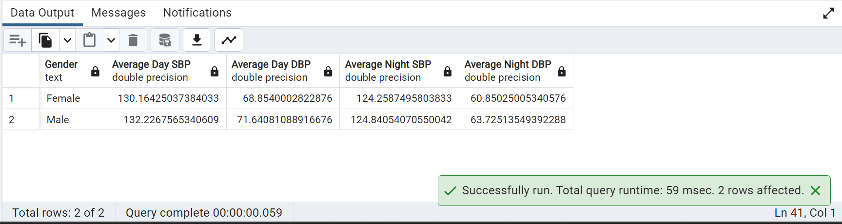

14. Calculate the average cholesterol level for each age group

SELECT CASE

WHEN p."Age" <= 55 THEN '50-55'

WHEN p."Age" <= 60 THEN '56-60'

WHEN p."Age" <= 65 THEN '61-65'

WHEN p."Age" <= 70 THEN '66-70'

ELSE '70+'

END AS "Age_Group",

ROUND(AVG(llt."Fasting_Cholestrol")::numeric,2) AS "Average_Cholesterol"

FROM public."Lipid_Lab_Test" llt,public."Patients" p

WHERE p."Patient_ID"=llt."Patient_ID"

GROUP BY "Age_Group"

ORDER BY "Age_Group";

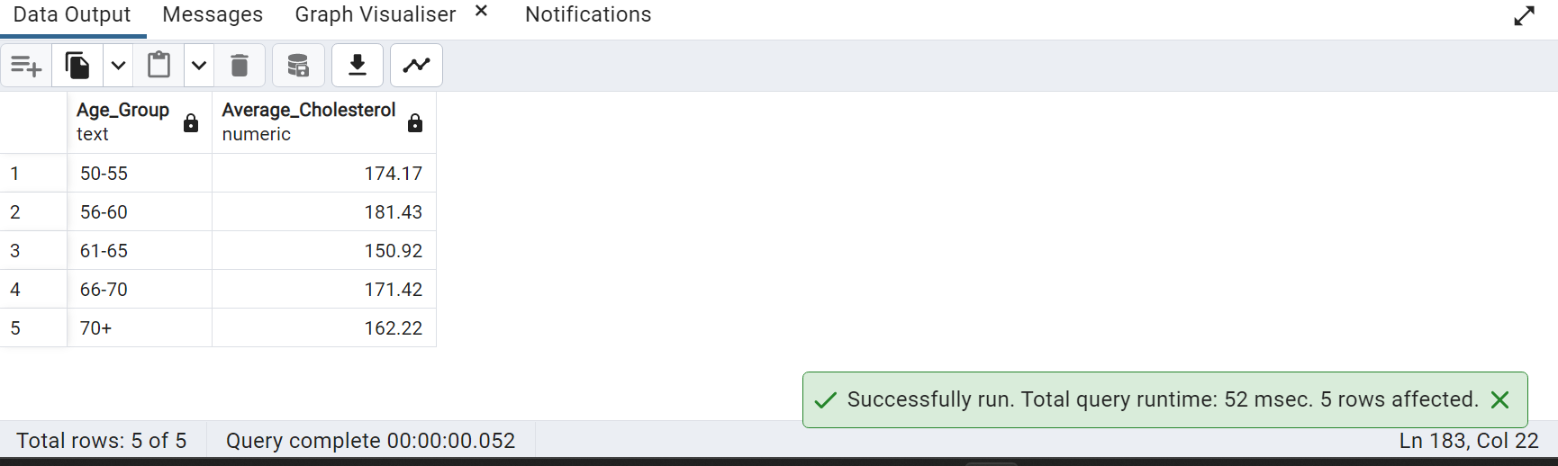

15. Get the latest lab test results for each patient:

SELECT p."Patient_ID",p."Firstname",p."Lastname",l."Lab_names",

lt."WBC",lt."RBC",lt."Hgb",lt."Hct",lt."Platelets",lt."Hb_A1C",lt."Fasting_Glucose",lt."Insulin"

FROM public."Patients" p,public."Lab_Visit" l,public."Lab_Test" lt,public."Link_Reference" lr

WHERE p."Patient_ID"=lt."Patient_ID" AND lr."Lab_visit_ID"=l."Lab_visit_ID"

AND l."Lab_Visit_Date"=

(SELECT MAX("Lab_Visit_Date") FROM public."Lab_Visit")

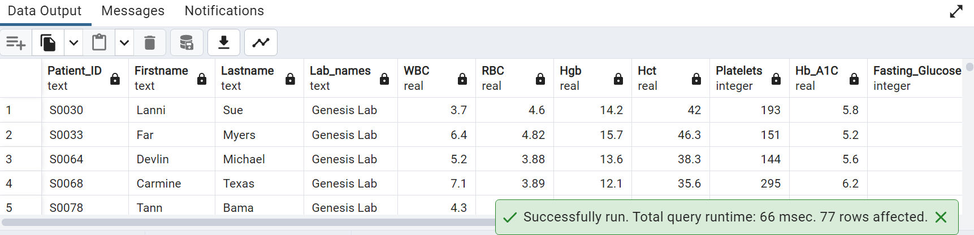

16. Get the average fasting glucose levels for diabetic patients by age group:

SELECT CASE

WHEN p."Age" BETWEEN 51 AND 55 THEN '51-55'

WHEN p."Age" BETWEEN 56 AND 60 THEN '56-60'

WHEN p."Age" BETWEEN 61 AND 65 THEN '61-65'

WHEN p."Age" BETWEEN 66 AND 70 THEN '61-65'

ELSE 'Above 70'

END AS "Age Group",ROUND(AVG(lt."Fasting_Glucose"),2)"Average Fasting Glucose"

FROM public."Patients" p,public."Lab_Test" lt

WHERE p."Patient_ID"=lt."Patient_ID"

AND p."Patient_ID" in

(SELECT "Patient_ID" FROM public."Patients" WHERE"Group_ID" in

(SELECT"Group_ID" FROM public."Group" WHERE "Group" = 'DM' ))

GROUP BY "Age Group" ORDER BY "Age Group" ;

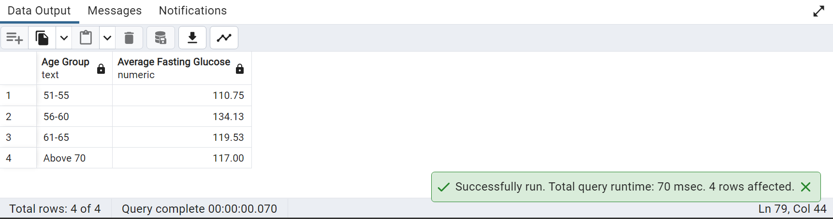

17. Get the count of male and female diabetic patients:

SELECT gr."Gender",count(*) As "Diabetic Patients" FROM public."Gender" gr,public."Group" gp, public."Patients" p

WHERE p."Group_ID"=gp."Group_ID" AND p."Gender_ID"=gr."Gender_ID"

AND gp."Group"='DM'

GROUP BY gr."Gender";

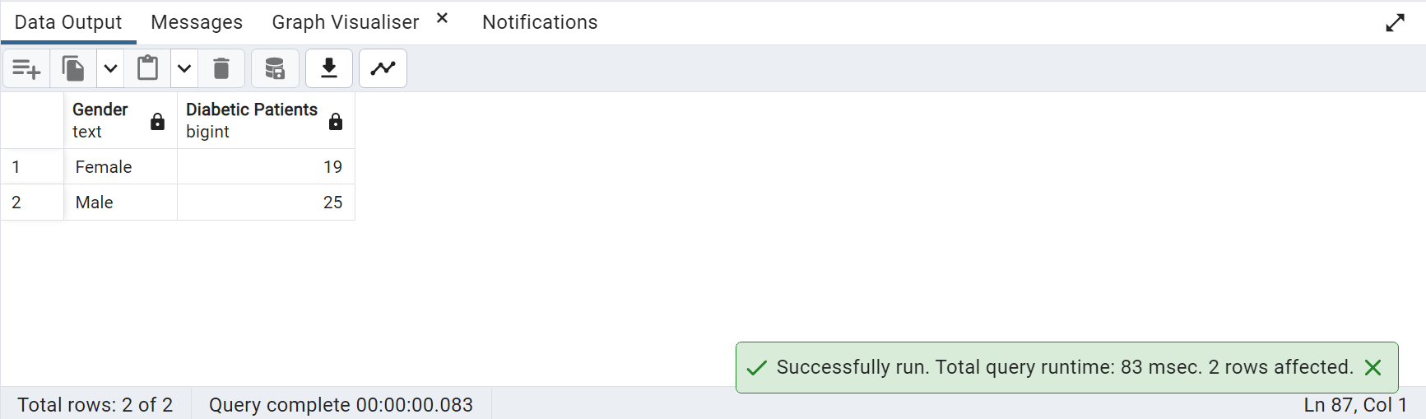

18. Write a query to return the last 2 digits of the Fasting_Cholestrol

select right(cast("Fasting_Cholestrol" as text),2) from public."Lipid_Lab_Test";

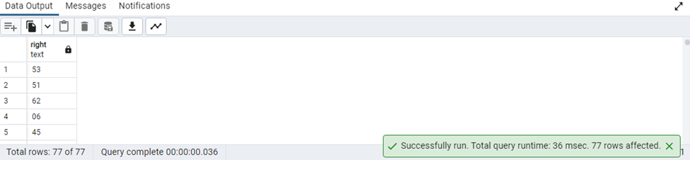

19. Write a query to find how many unique patients there are in public."Blood_Pressure".

select count(distinct "Patient_ID") as count_of_unique_patient from public."Blood_Pressure"

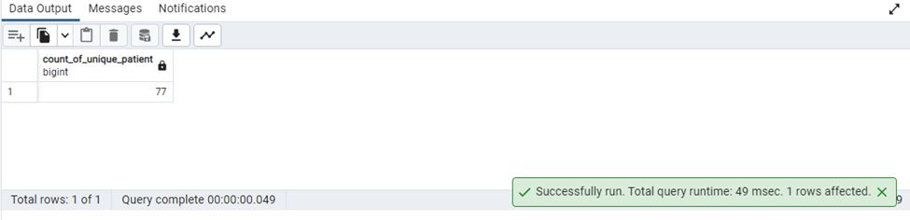

20.Write a query to show the count of patients as per Race.

select "Race", count(distinct "Patient_ID") as Patients from public."Patients"as pa inner join public."Race" as r on pa."Race_ID" = r."Race_ID" group by "Race";

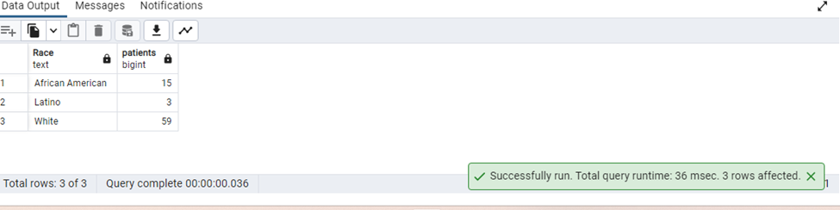

21.Write a query using ARRAY_AGG function to get a list of Patient names and Race.

SELECT ARRAY_AGG(CONCAT(P."Firstname",' ',P."Lastname") || ' ' || R. "Race") FROM public."Patients" P, public."Race" R where P."Race_ID" =R."Race_ID" GROUP BY P."Patient_ID" ORDER BY P."Patient_ID";

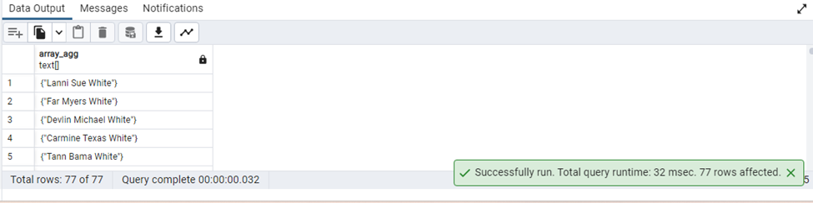

22.write a query to get the list of patient ids which are not there in Lab_Test.

SELECT DISTINCT P."Patient_ID"

FROM "Patients" P

WHERE P."Patient_ID" NOT IN

(SELECT LT."Patient_ID" FROM

public."Lab_Test" LT);

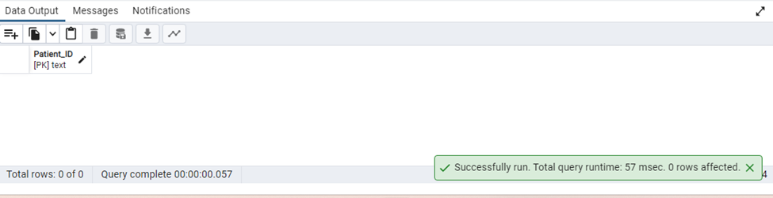

23.Write a query to find the 7 characters of Firstname in lower cases.

SELECT LOWER(LEFT("Firstname",5)) as FIRST_5_character

FROM public."Patients";

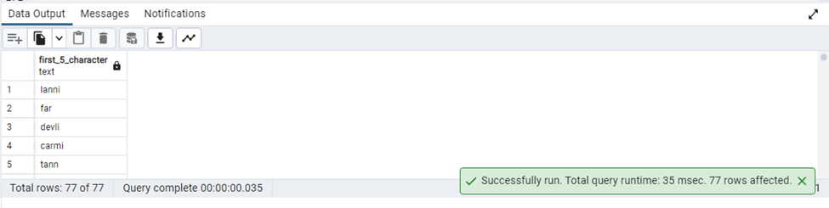

24.List all the Patients whose Hgb is above the actual range

select concat(pt."Firstname"||' '||pt."Lastname") Fullname, pt."Link_Reference_ID",lt."Hgb" from "Patients" pt join "Link_Reference" lr on pt."Link_Reference_ID"=lr."Link_Reference_ID"join "Lab_Test" lt on lt."Lab_ID"=lr."Lab_ID"where lt."Hgb">15;

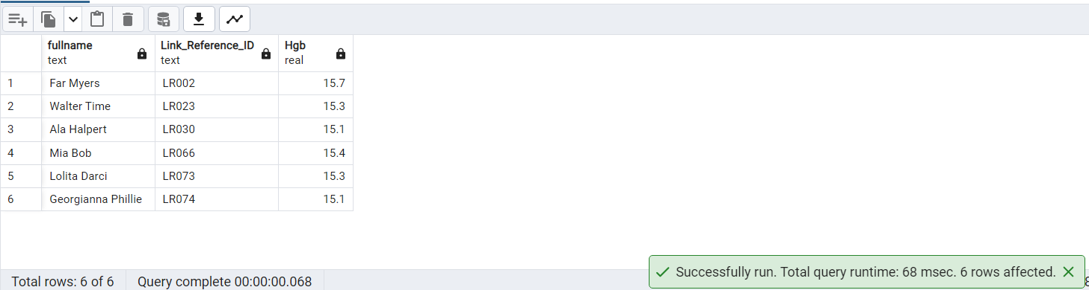

25.Write a query using the Dense_Rank function for Patients table.

Select "Patient_ID","Group_ID","Opthal_ID",

DENSE_RANK() OVER(

PARTITION BY "Opthal_ID"

ORDER BY "WalkTest_ID")Walk_Rank

FROM Public."Patients";

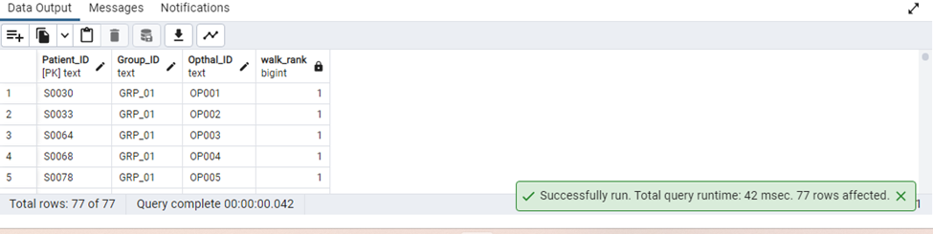

26) heart rate across age groups

SELECT

CONCAT((FLOOR(P."Age" / 5) * 5), '-', (FLOOR(P."Age" / 5) * 5 + 4)) AS "Age_Group",

ROUND(AVG((BP."24Hr_Day_HR" + BP."24Hr_Night_HR") / 2)::numeric, 2) AS "Average_Heart_Rate"

FROM public."Blood_Pressure" BP

JOIN public."Patients" P ON P."BP_ID" = BP."BP_ID"

GROUP BY CONCAT((FLOOR(P."Age" / 5) * 5), '-', (FLOOR(P."Age" / 5) * 5 + 4))

ORDER BY "Age_Group";

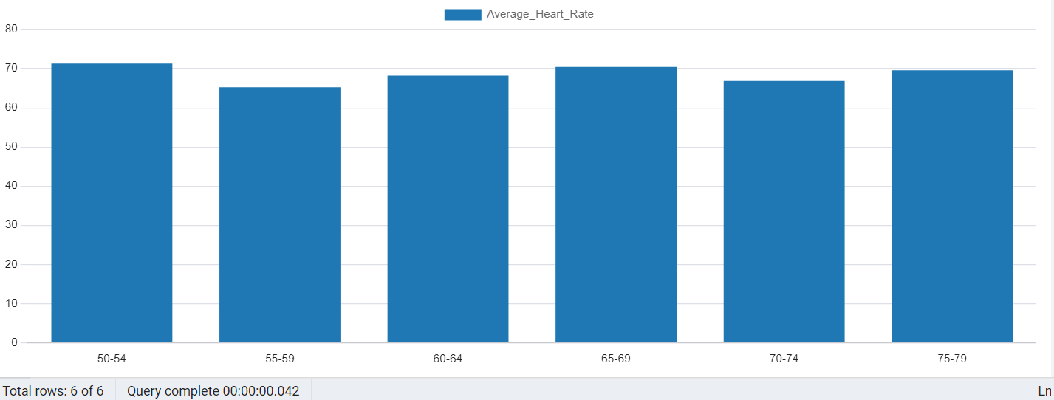

27. percentage distribution of race.

SELECT R."Race",COUNT(*) AS "Count",

ROUND(COUNT(*) * 100.0 / (SELECT COUNT(*) FROM public."Patients"), 2) AS "Percentage"

FROM public."Patients" P

JOIN public."Race" R ON P."Race_ID" = R."Race_ID"

GROUP BY R."Race"

ORDER BY R."Race";

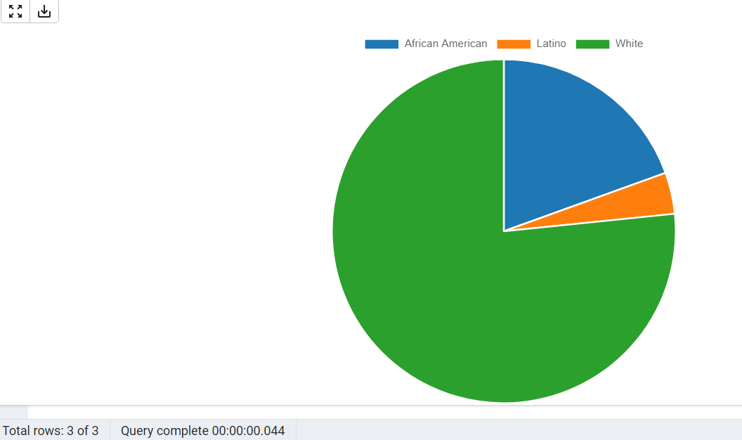

28)Bar chart to show count of Patients of each race.

Select COUNT("Patient_ID") as "Patient","Race" from "Patients"

inner join "Race" ON "Patients"."Race_ID" ="Race"."Race_ID"

group by "Race". "Race_ID";

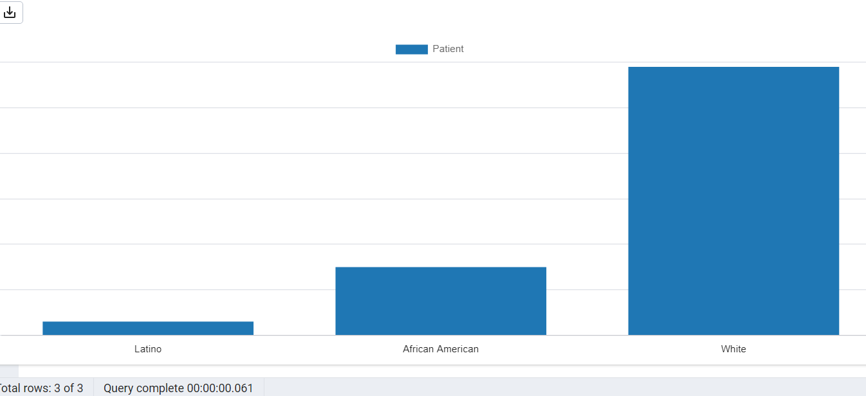

29. Create a bar chart for average fasting glucose levels for diabetic patients by age group:

SELECT CASE

WHEN p."Age" BETWEEN 51 AND 55 THEN '51-55'

WHEN p."Age" BETWEEN 56 AND 60 THEN '56-60'

WHEN p."Age" BETWEEN 61 AND 65 THEN '61-65'

WHEN p."Age" BETWEEN 66 AND 70 THEN '61-65'

ELSE 'Above 70'

END AS "Age Group",ROUND(AVG(lt."Fasting_Glucose"),2)"Average Fasting Glucose"

FROM public."Patients" p,public."Lab_Test" lt

WHERE p."Patient_ID"=lt."Patient_ID"

AND p."Patient_ID" in

(SELECT "Patient_ID" FROM public."Patients" WHERE"Group_ID" in

(SELECT"Group_ID" FROM public."Group" WHERE "Group" = 'DM' ))

GROUP BY "Age Group" ORDER BY "Age Group" ;

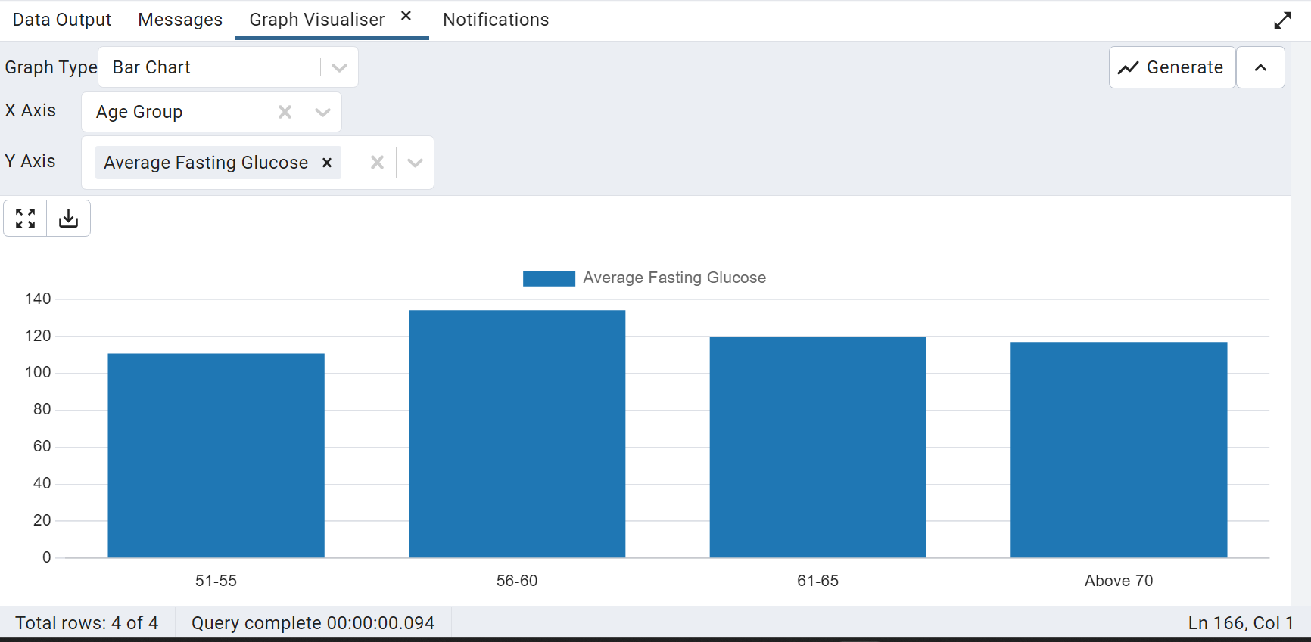

30. Create a line chart to show how Day HR changes with Night HR

SELECT * from public."Blood_Pressure";

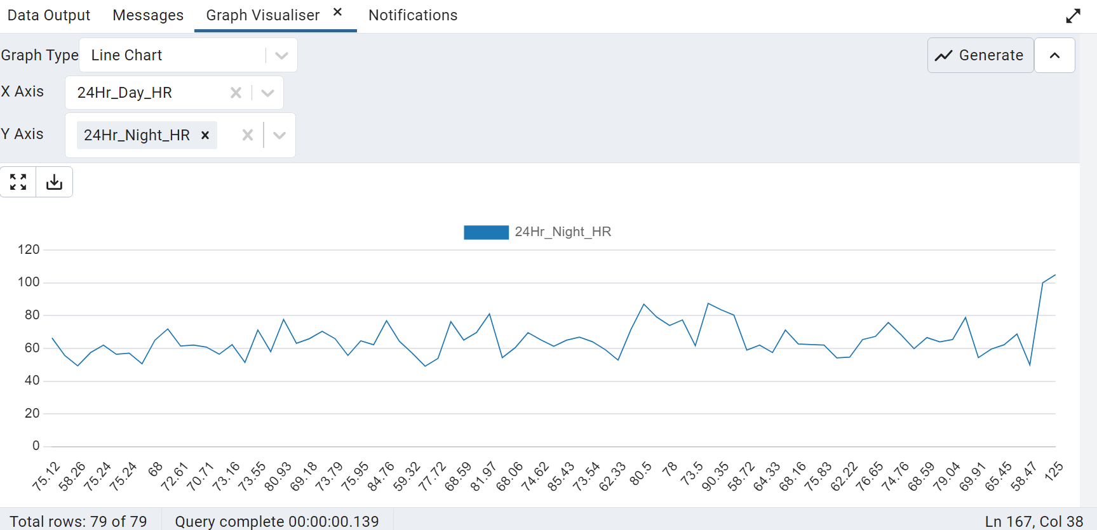

31. Show relationship between fasting glucose and Insulin visually

SELECT * from public."Lab_Test";

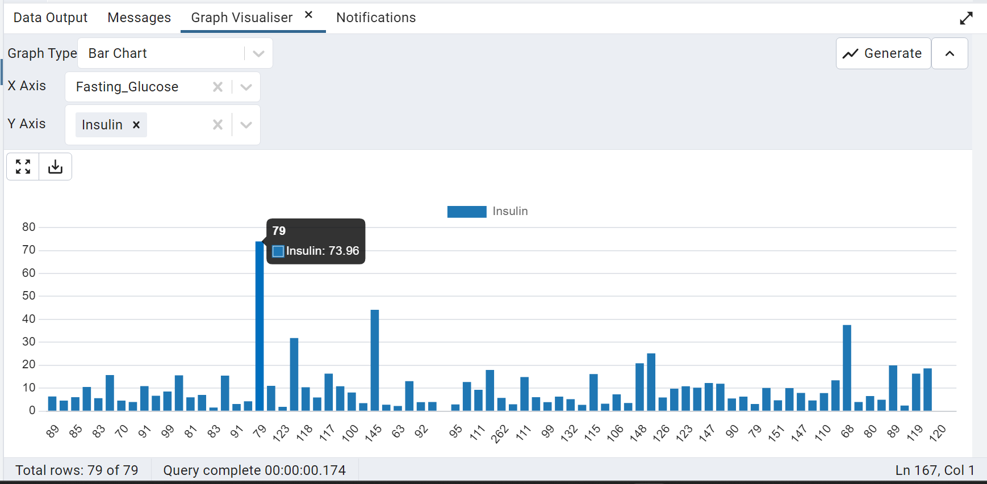

32. Create a pie chart to show male and female diabetic patients

SELECT gr."Gender",count(*) As "Diabetic Patients" FROM public."Gender" gr,public."Group" gp, public."Patients" p

WHERE p."Group_ID"=gp."Group_ID" AND p."Gender_ID"=gr."Gender_ID"

AND gp."Group"='DM'

GROUP BY gr."Gender";

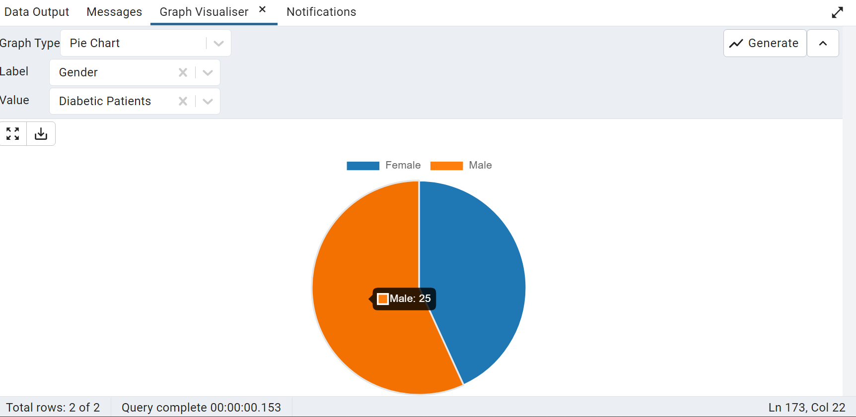

33. Calculate the average Hemoglobin A1C level for diabetic patients and non diabetic patients

SELECT g."Group",ROUND(AVG(lt."Hb_A1C")::numeric,2) As "Avg Hemoglobin A1C level" FROM public."Lab_Test" lt,public."Patients" p,public."Group" g

WHERE lt."Patient_ID" = p."Patient_ID"

AND p."Group_ID"=g."Group_ID"

GROUP BY g."Group";

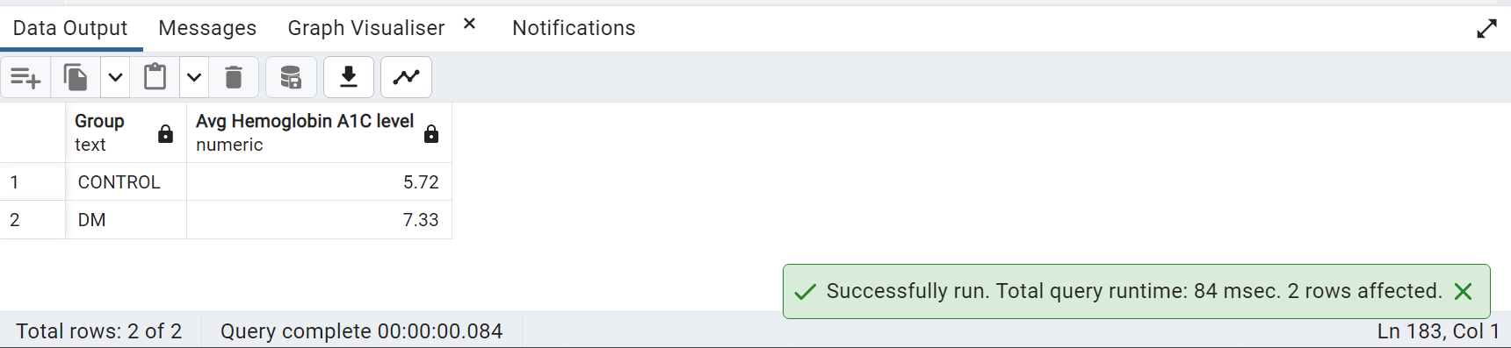

34.Find patients with high blood pressure:

SELECT DISTINCT CONCAT(p."Firstname", ' ', p."Lastname") AS "Patients with high blood pressure"

FROM public."Patients" p

JOIN public."Blood_Pressure" bp ON p."Patient_ID" = bp."Patient_ID"

WHERE (bp."24Hr_Day_SBP" > 135 AND bp."24Hr_Day_DBP" > 85)

OR (bp."24Hr_Night_SBP" > 120 AND bp."24Hr_Night_DBP" > 70);

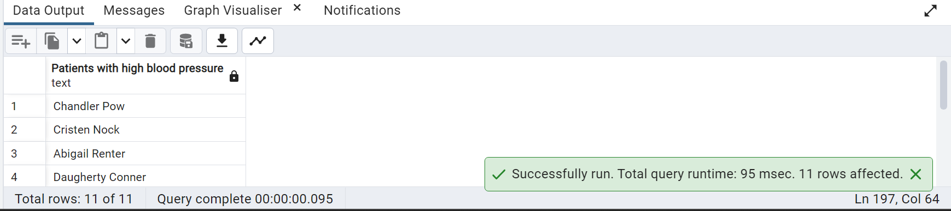

35. Calculate the average Age of male and female patients

SELECT g."Gender",ROUND(AVG(p."Age"),2) AS "Average Age" FROM public."Patients" p

JOIN public."Gender" g ON p."Gender_ID"=g."Gender_ID"

GROUP BY g."Gender"

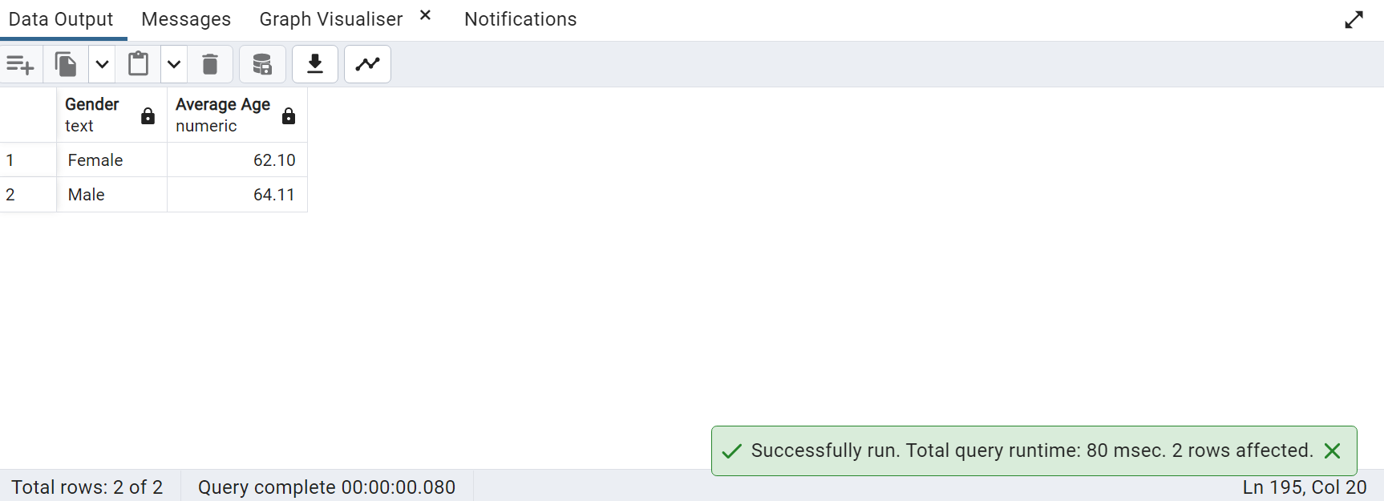

36. Calculate number of patients in each Diabetic Category

SELECT COUNT(*),CASE

WHEN "Fasting_Glucose" < 70 THEN 'HYPOGLYCEMIA'

WHEN "Fasting_Glucose" BETWEEN 70 AND 100 THEN 'NORMAL'

WHEN "Fasting_Glucose" BETWEEN 100 AND 120 THEN 'PREDIABETIC'

WHEN "Fasting_Glucose" > 120 THEN 'Diabetic' END AS "Diabetic Status"

FROM public."Lab_Test"

WHERE "Fasting_Glucose" IS NOT NULL

GROUP BY "Diabetic Status"

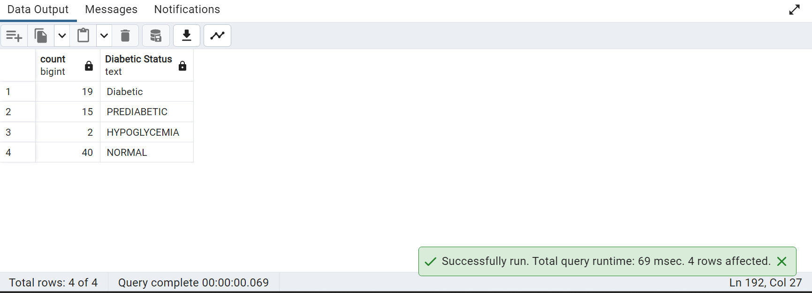

37. Create a bar chart for diabetic status of patients

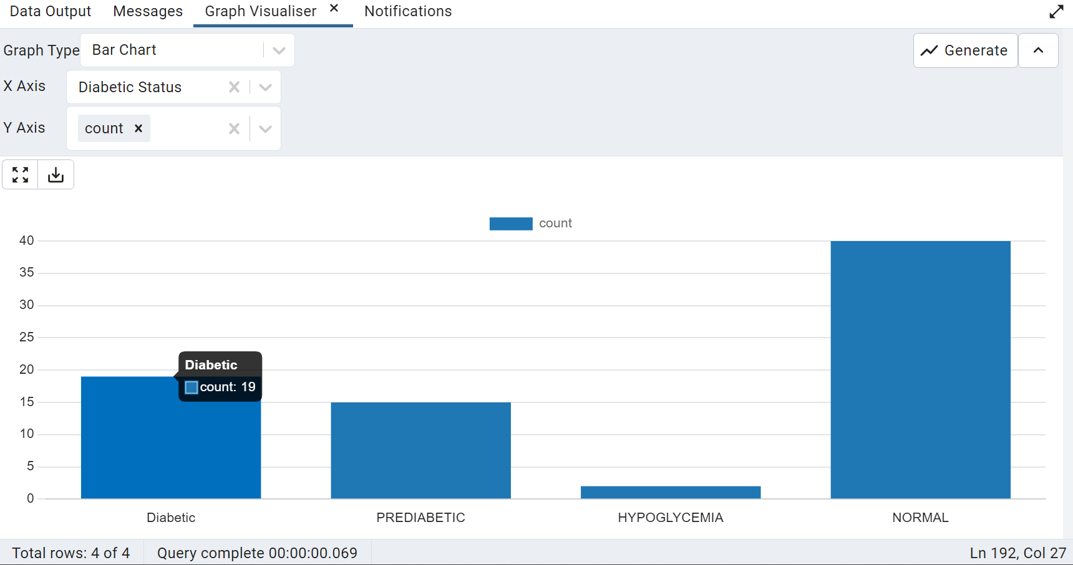

38. Write a query to find the WBC level of patients

SELECT COUNT("Patient_ID") AS "PATIENT COUNT",

CASE WHEN "WBC" <4.5 THEN 'LEUKOPENIA'

WHEN "WBC" BETWEEN 4.5 AND 11 THEN 'NORMAL'

WHEN "WBC" >11 THEN 'LEUKOCYTOSIS' END AS "WBC Condition"

FROM public."Lab_Test"

WHERE "WBC" IS NOT NULL

GROUP BY "WBC Condition";

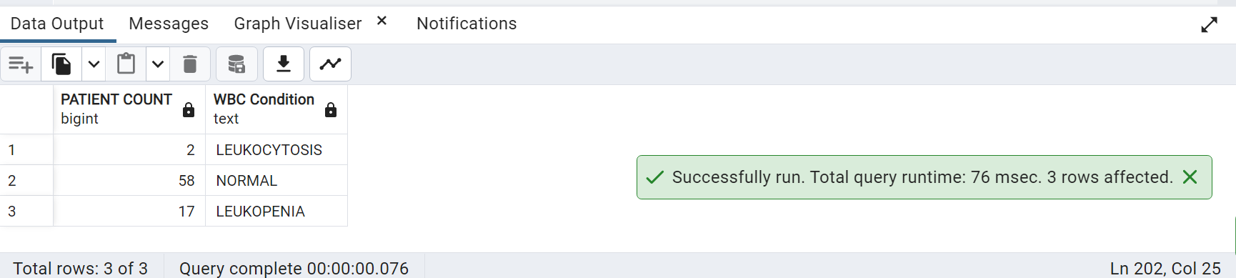

39. Create a bar chart to show abnormality in WBC count

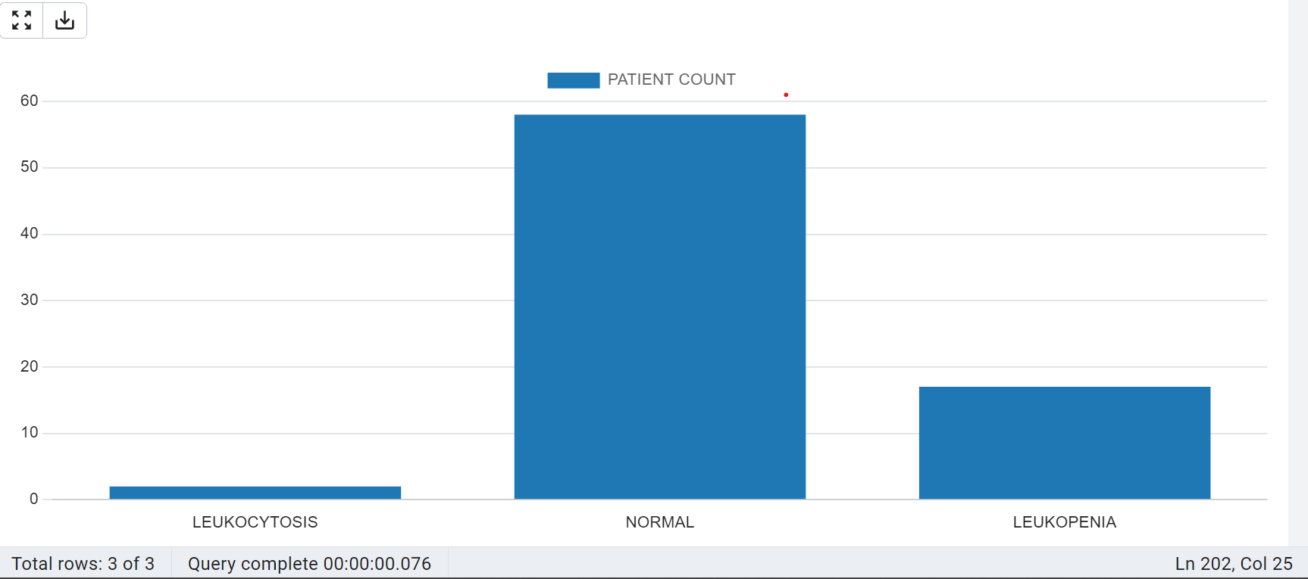

40. Calculate number of patients who visited each lab

SELECT COUNT(*),lv."Lab_names" FROM

public."Lab_Visit" lv, public."Patients" p,public."Link_Reference" lr

WHERE lv."Lab_visit_ID"=lr."Lab_visit_ID"

AND p."Link_Reference_ID"=lr."Link_Reference_ID"

GROUP BY lv."Lab_names";

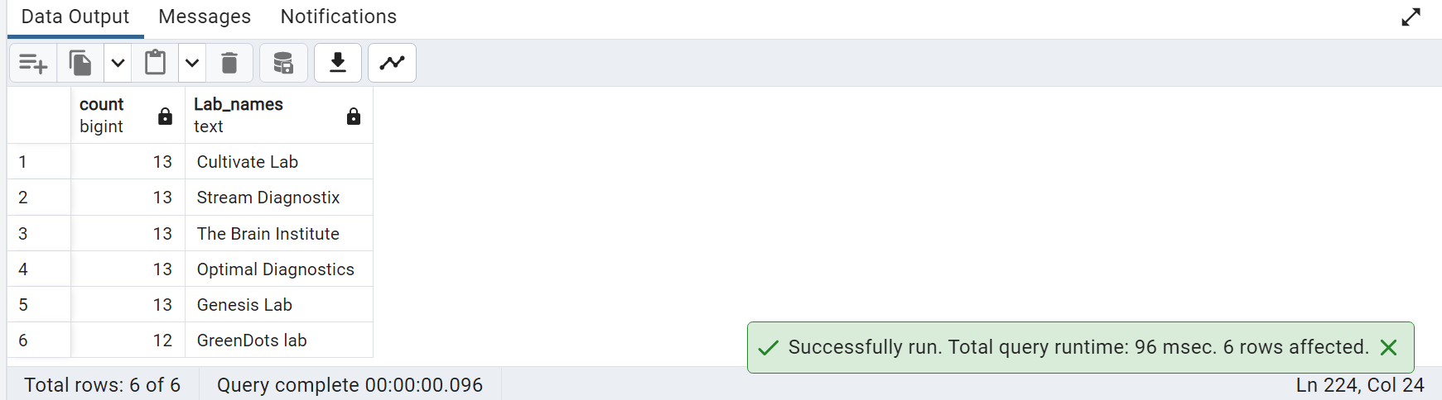

41. Create a visualization to find patients with normal and abnormal platelet range

SELECT

CASE WHEN lt."Platelets" BETWEEN 150 AND 450 THEN 'Normal'

ELSE 'Abnormal'

END As "Platelets Range",count(*)

FROM public."Lab_Test" lt

JOIN public."Patients" p ON p."Patient_ID"=lt."Patient_ID"

GROUP BY "Platelets Range";

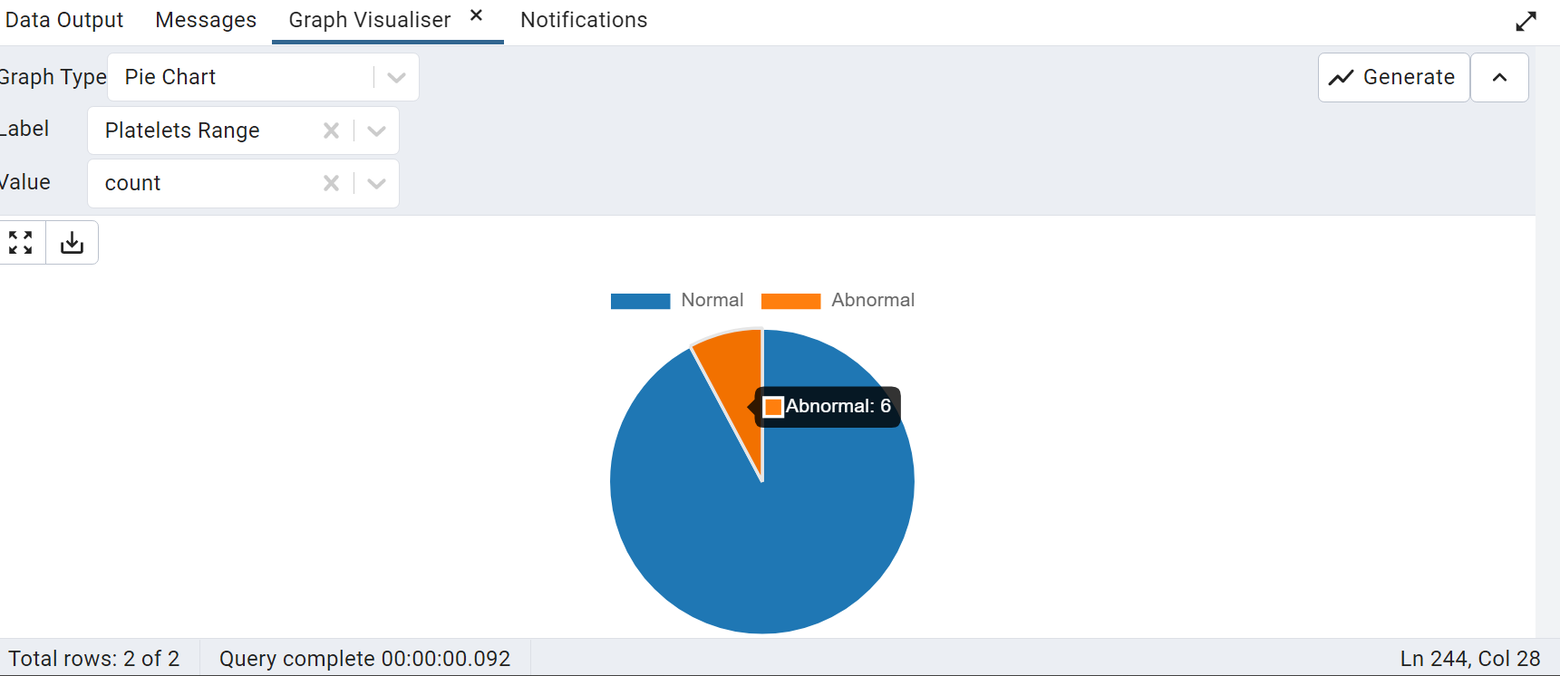

42. Write a query to find number of patients in BMI category

SELECT

CASE WHEN "BMI" < 18.5 THEN 'Underweight'

WHEN "BMI" BETWEEN 18.5 AND 24.9 THEN 'Normal'

WHEN "BMI" BETWEEN 25 AND 29.9 THEN 'Overweight'

ELSE 'OBESE' END AS "BMI Category",COUNT(*)

FROM public."Patients"

GROUP BY "BMI Category";

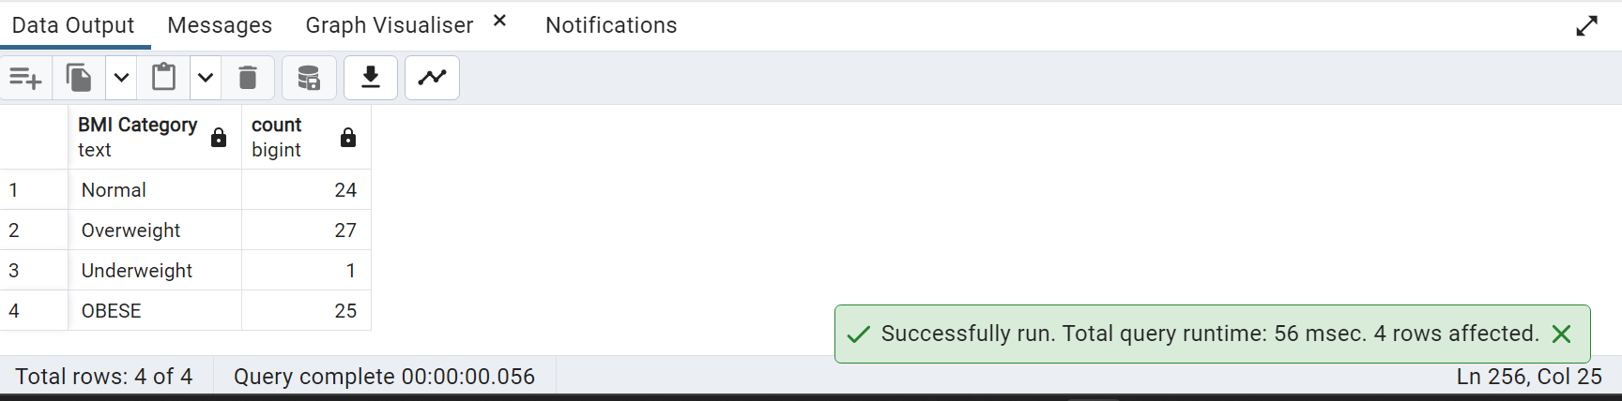

43. Find number of diabetic patients who are not in normal weight

SELECT COUNT(*)As "ABNORMAL WEIGHT DIABETIC PATIENTS" FROM public."Patients" p,public."Group" gp

WHERE p."Group_ID"=gp."Group_ID"

AND gp."Group"='DM'

AND p."BMI">24.9

GROUP BY gp."Group";

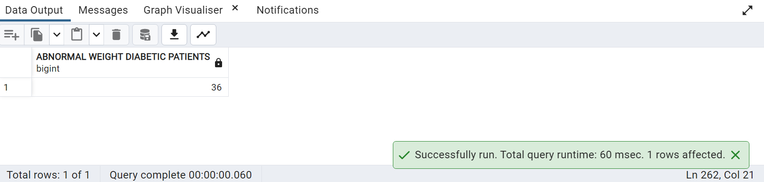

44. Find male and female patients who are overweight

SELECT COUNT(*)As "Overweight Patients", g."Gender" FROM public."Patients" p, public."Gender" g

WHERE p."Gender_ID"=g."Gender_ID"

AND p."BMI">24.9

GROUP BY g."Gender"

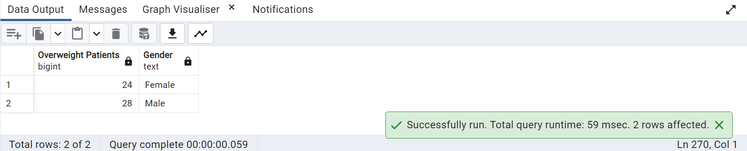

45. WRITE A QUERY TO FIND OUT PATIENT NAME ,WHO HAS DEMENTIA/COGNITIVE IMPAIREMENT

SELECT CONCAT (PT."Firstname",' ',PT."Lastname")

FROM PUBLIC."Visual/Motor_Cog" VM

JOIN PUBLIC."Link_Reference" LR ON LR."VM_ID" = VM."VM_ID"

JOIN PUBLIC."Patients" PT ON PT."Link_Reference_ID" = LR."Link_Reference_ID"

WHERE VM."TM" >= 42;

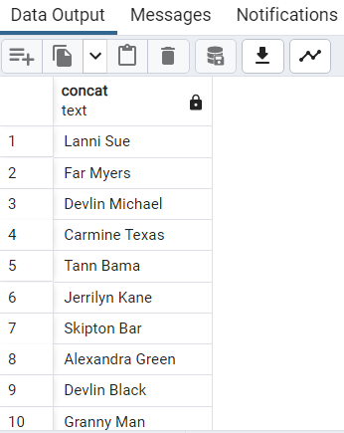

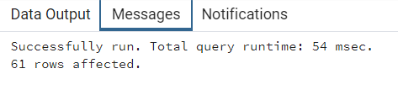

46. Create a pie chart to show overweight patients by race

SELECT COUNT(*) As "Overweight Patients",r."Race"

FROM public."Race" r,public."Patients" p

WHERE p."Race_ID"=r."Race_ID"

AND p."BMI"> 24.9

GROUP BY r."Race";

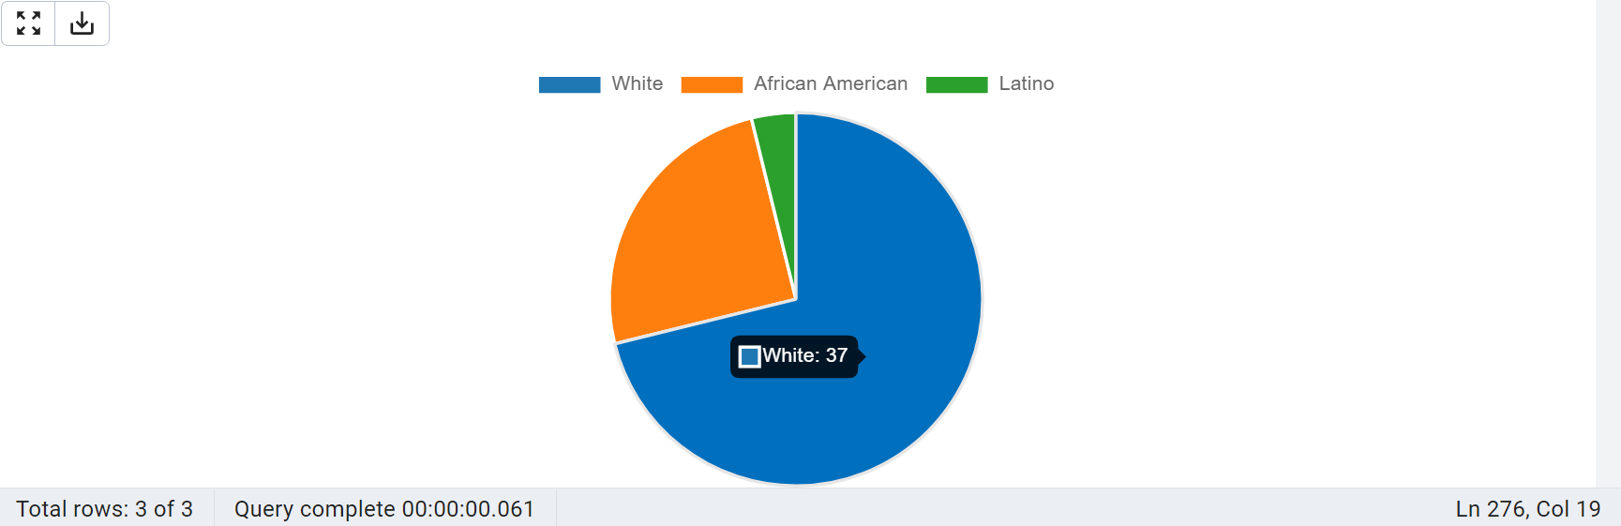

47) Return the version

SELECT VERSION();

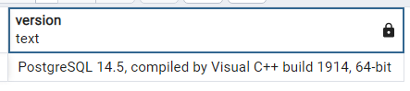



48) Average heart rate on age bin

SELECT

CONCAT((WIDTH_BUCKET(p."Age", 0, 100, 20) - 1) * 5, ' - ', WIDTH_BUCKET(p."Age", 0, 100, 20) * 5 - 1) AS age_range,

CAST(AVG((bp."24Hr_Day_HR" + bp."24Hr_Night_HR") / 2.0) AS DECIMAL(10, 2)) AS avg_HR

FROM public."Patients" p

JOIN public."Blood_Pressure" bp ON p."BP_ID" = bp."BP_ID"

GROUP BY WIDTH_BUCKET(p."Age", 0, 100, 20)

ORDER BY WIDTH_BUCKET(p."Age", 0, 100, 20);

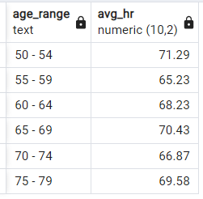



49) Average heart rate on age bin pie chart

SELECT

CONCAT((WIDTH_BUCKET(p."Age", 0, 100, 20) - 1) * 5, ' - ', WIDTH_BUCKET(p."Age", 0, 100, 20) * 5 - 1) AS age_range,

COUNT (*) AS PATIENT_COUNT

FROM PUBLIC."Patients" P

GROUP BY WIDTH_BUCKET(p."Age", 0, 100, 20)

ORDER BY age_range ASC;

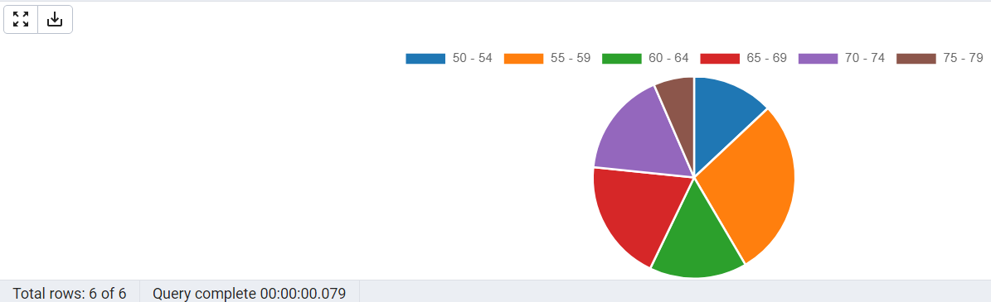



50) HCT Conditions mapped

SELECT P."Patient_ID",

CASE

WHEN G."Gender" = 'Male' AND LT."Hct" < 41 THEN 'ANEMIA'

WHEN G."Gender" = 'Male' AND LT."Hct" >=41 AND LT."Hct" <= 50 THEN 'NORMAL'

WHEN G."Gender" = 'Male' AND LT."Hct" > 50 THEN 'High Hematocrit'

WHEN G."Gender" = 'Female' AND LT."Hct" <36 THEN 'ANEMIA'

WHEN G."Gender" = 'Female' AND LT."Hct" >=36 AND LT."Hct" <= 48 THEN 'NORMAL'

WHEN G."Gender" = 'Female' AND LT."Hct" > 48 THEN 'High Hematocrit'

END AS "Hematocrit"

FROM public."Lab_Test" LT

JOIN public."Patients" P ON P."Patient_ID" = LT."Patient_ID"

JOIN public."Gender" G ON G."Gender_ID" = P."Gender_ID";

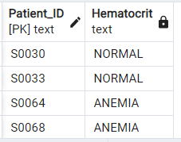



51) HCT Distribution pie chart

SELECT

CASE

WHEN G."Gender" = 'Male' AND LT."Hct" < 41 THEN 'ANEMIA'

WHEN G."Gender" = 'Male' AND LT."Hct" >= 41 AND LT."Hct" <= 50 THEN 'NORMAL'

WHEN G."Gender" = 'Male' AND LT."Hct" > 50 THEN 'High Hematocrit'

WHEN G."Gender" = 'Female' AND LT."Hct" < 36 THEN 'ANEMIA'

WHEN G."Gender" = 'Female' AND LT."Hct" >= 36 AND LT."Hct" <= 48 THEN 'NORMAL'

WHEN G."Gender" = 'Female' AND LT."Hct" > 48 THEN 'High Hematocrit'

END AS "Hematocrit",

COUNT(P."Patient_ID") AS "Patient_Count"

FROM public."Lab_Test" LT

JOIN public."Patients" P ON P."Patient_ID" = LT."Patient_ID"

JOIN public."Gender" G ON G."Gender_ID" = P."Gender_ID"

GROUP BY "Hematocrit";

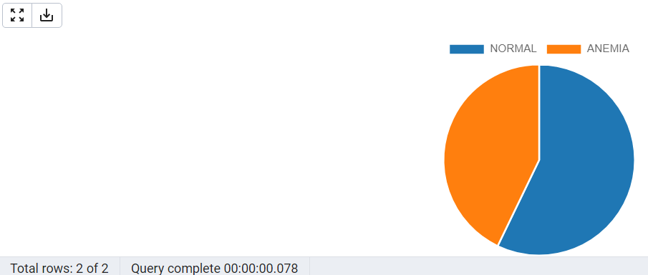

52)GAIT_SPEED RANGE MAPPING

SELECT P."Patient_ID",

CASE

WHEN G."Gender" = 'Male' AND "Gait_DT_Speed" < 1.08 THEN 'LOW'

WHEN G."Gender" = 'Female' AND "Gait_DT_Speed" < 0.92 THEN 'LOW'

ELSE 'NORMAL'

END AS "GAIT_SPEED"

FROM public."Walking_Test" WT

JOIN public."Patients" P ON P."WalkTest_ID" = WT."WalkTest_ID"

JOIN public."Gender" G ON G."Gender_ID" = P."Gender_ID";

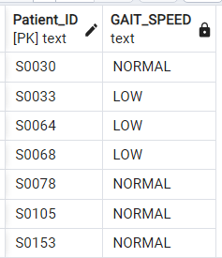



53) GAIT_SPEED DISTRIBUTION

SELECT

CASE

WHEN G."Gender" = 'Male' AND "Gait_DT_Speed" < 1.08 THEN 'LOW'

WHEN G."Gender" = 'Female' AND "Gait_DT_Speed" < 0.92 THEN 'LOW'

ELSE 'NORMAL'

END AS "GAIT_SPEED",

COUNT(P."Patient_ID") AS "PATIENT_COUNT"

FROM public."Walking_Test" WT

JOIN public."Patients" P ON P."WalkTest_ID" = WT."WalkTest_ID"

JOIN public."Gender" G ON G."Gender_ID" = P."Gender_ID"

GROUP BY "GAIT_SPEED";

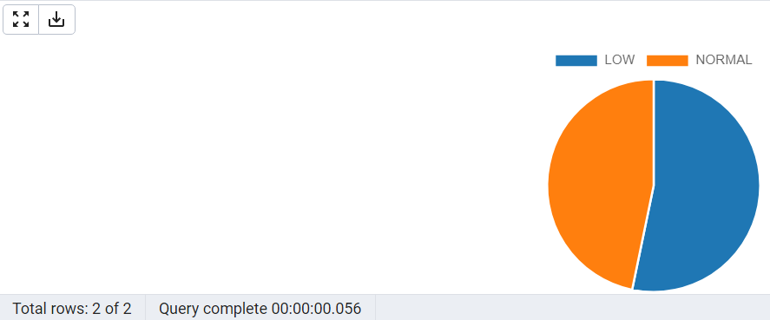

54) Average heart rate on age bin pipe chart

SELECT

CONCAT((WIDTH_BUCKET(p."Age", 0, 100, 20) - 1) * 5, ' - ', WIDTH_BUCKET(p."Age", 0, 100, 20) * 5 - 1) AS age_range,

COUNT (*) AS PATIENT_COUNT 69

FROM PUBLIC."Patients" P

GROUP BY WIDTH_BUCKET(p."Age", 0, 100, 20)

ORDER BY age_range ASC;

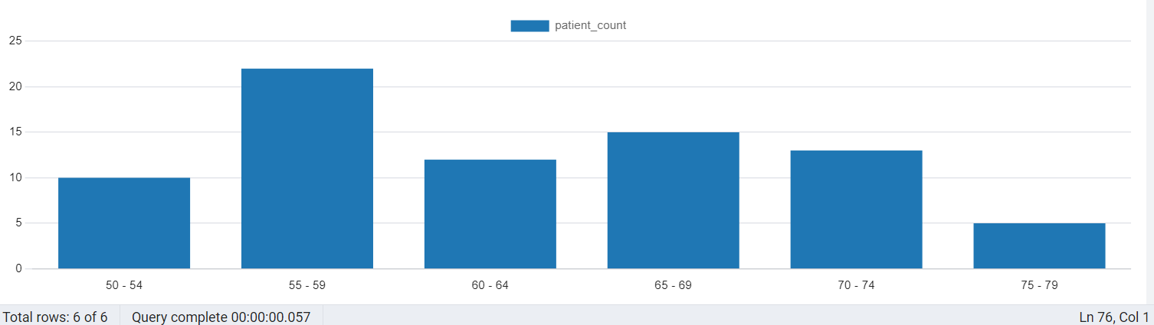

55) distribution of patients with abnormal insulin

SELECT

CASE

WHEN LT."Insulin" < 2.6 THEN 'Low Insulin'

WHEN LT."Insulin" >= 2.6 AND LT."Insulin" <= 24.9 THEN 'Normal Insulin'

WHEN LT."Insulin" > 24.9 THEN 'High Insulin'

END AS "Insulin_Level",

COUNT(*) AS "Patient_Count"

FROM public."Lab_Test" LT

GROUP BY "Insulin_Level";

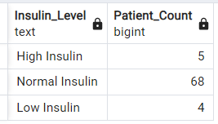



56) check schema

SELECT current_schema();

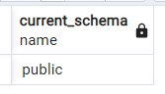



57) check for null values

SELECT table_name, column_name

FROM information_schema.columns

WHERE table_schema = 'public'

AND column_name IN (

SELECT column_name

FROM public."Patients"

WHERE column_name IS NULL

);





58)The name of the current user in PostgreSQL.

SELECT CURRENT_USER;

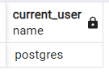



59)Return the name of the current database in PostgreSQL

SELECT current_database();

60)Return the process ID (PID) of the current PostgreSQL database connection.

SELECT pg_backend_pid();

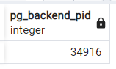



61) abnormal insulin to abnormal platelet study

SELECT

CASE

WHEN LT."Insulin" < 2.6 THEN 'Low Insulin'

WHEN LT."Insulin" >= 2.6 AND LT."Insulin" <= 24.9 THEN 'Normal Insulin'

WHEN LT."Insulin" > 24.9 THEN 'High Insulin'

END AS "Insulin_Level",

COUNT(*) AS "Patient_Count"

FROM public."Lab_Test" LT

WHERE LT."Platelets" < 150 OR LT."Platelets" > 450

GROUP BY "Insulin_Level";

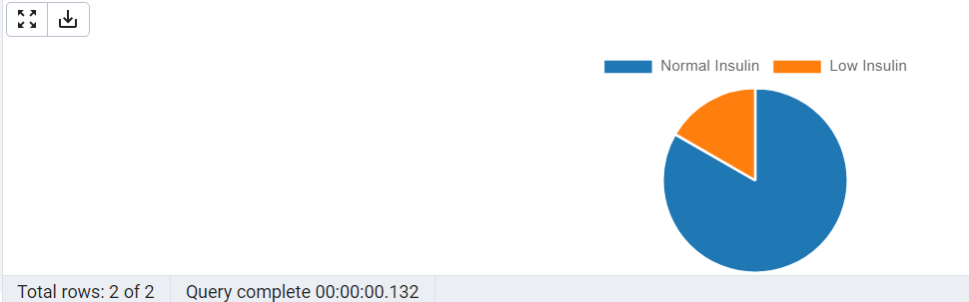

62) Comprehensive study

CREATE OR REPLACE VIEW patient_info AS

SELECT

P."Patient_ID",

CONCAT(P."Firstname", ' ', P."Lastname") AS "Full_Name",

G."Gender",

P."Age",

R."Race",

LV."Lab_names",

CASE

WHEN GR."Group" = 'DM' THEN 'Diabetic'

ELSE 'Control'

END AS "Group",

CASE

WHEN (((BP."24Hr_Day_SBP" + 2 * BP."24Hr_Day_DBP") / 3) < 70) OR (((BP."24Hr_Night_SBP" + 2 * BP."24Hr_Night_DBP") / 3) < 70) THEN 'Low'

WHEN (((BP."24Hr_Day_SBP" + 2 * BP."24Hr_Day_DBP") / 3) >= 70 AND ((BP."24Hr_Day_SBP" + 2 * BP."24Hr_Day_DBP") / 3) <= 100) OR (((BP."24Hr_Night_SBP" + 2 * BP."24Hr_Night_DBP") / 3) >= 70 AND ((BP."24Hr_Night_SBP" + 2 * BP."24Hr_Night_DBP") / 3) <= 100) THEN 'Normal'

ELSE 'High'

END AS "Map",

CASE

WHEN O."Macular_Edema" <> 0 THEN 'Macular_Edema'

WHEN O."Diabetic_Retinopathy" <> 0 THEN 'Diabetic_Retinopathy'

ELSE 'No'

END AS "Eye_Damage",

CASE

WHEN L."Fasting_Cholestrol" < 150 THEN 'Normal'

ELSE 'High'

END AS "Cholesterol",

CASE

WHEN LT."Fasting_Glucose" <= 70 THEN 'Hypoglycemia'

WHEN LT."Fasting_Glucose" > 70 AND LT."Fasting_Glucose" <= 100 THEN 'Normal'

WHEN LT."Fasting_Glucose" > 100 AND LT."Fasting_Glucose" <= 120 THEN 'Pre_Diabetic'

ELSE 'Diabetic'

END AS "Insulin",

CONCAT_WS(',',

CASE WHEN MC."IADL" <= 14 THEN 'IADL' END,

CASE WHEN MC."MMSE" <= 23 THEN 'MMSE' END,

CASE WHEN MC."GDS" >= 15 THEN 'GDS' END,

CASE WHEN VMC."RCFT_IR" <= 71 THEN 'RCFT_IR' END,

CASE WHEN VMC."TM" >= 42 THEN 'TM' END,

CASE WHEN VMC."Clock" <= 2 THEN 'Clock' END,

CASE WHEN VC."DS" < 13 THEN 'DS' END,

CASE WHEN VC."HVLT" < 19 THEN 'HVLT' END,

CASE WHEN VC."VF" < 42 THEN 'VF' END,

CASE WHEN VC."WTAR" <= 20 THEN 'WTAR' END

) AS "Dementia",

CASE

WHEN U."Creatinine" IS NOT NULL AND U."Albumin" IS NOT NULL THEN

CASE

WHEN G."Gender" = 'Male' AND U."Creatinine" BETWEEN 65.4 AND 119.3 AND U."Albumin" BETWEEN 3.4 AND 5.4 THEN 'Normal'

WHEN G."Gender" = 'Female' AND U."Creatinine" BETWEEN 52.2 AND 91.9 AND U."Albumin" BETWEEN 3.4 AND 5.4 THEN 'Normal'

WHEN G."Gender" = 'Male' AND (U."Creatinine" < 65.4 OR U."Creatinine" > 119.3) THEN 'A.Creat'

WHEN G."Gender" = 'Female' AND (U."Creatinine" < 52.2 OR U."Creatinine" > 91.9) THEN 'A.Creat'

WHEN U."Albumin" < 3.4 OR U."Albumin" > 5.4 THEN 'A.Alb'

ELSE 'A.Creat, A.Alb'

END

END AS "Lipid"

FROM

public."Patients" P

JOIN public."Gender" G ON G."Gender_ID" = P."Gender_ID"

JOIN public."Race" R ON R."Race_ID" = P."Race_ID"

JOIN public."Blood_Pressure" BP ON BP."BP_ID" = P."BP_ID"

JOIN public."Opthalmology" O ON O."Opthal_ID" = P."Opthal_ID"

JOIN public."Walking_Test" WT ON WT."WalkTest_ID" = P."WalkTest_ID"

JOIN public."Link_Reference" LR ON LR."Link_Reference_ID" = P."Link_Reference_ID"

JOIN public."Urine_Test" U ON U."Urine_ID" = LR."Urine_ID"

JOIN public."Lipid_Lab_Test" L ON L."Lipid_ID" = LR."Lipid_ID"

JOIN public."Memory_Cognitive" MC ON MC."MC_ID" = LR."MC_ID"

JOIN public."Visual/Motor_Cog" VMC ON VMC."VM_ID" = LR."VM_ID"

JOIN public."Verbal_Cognitive" VC ON VC."VC_ID" = LR."VC_ID"

JOIN public."Lab_Test" LT ON LT."Lab_ID" = LR."Lab_ID"

JOIN public."Group" GR ON GR."Group_ID" = P."Group_ID"

JOIN public."Lab_Visit" LV ON LV."Lab_visit_ID" = LR."Lab_visit_ID";

SELECT * FROM patient_info



63) checking if all patients in diabetic group have diabetic duration

SELECT P."Patient_ID"

FROM public."Patients" P

WHERE P."Diabetes_Duration"=0

AND P."Group_ID" IN (SELECT "Group_ID" FROM public."Group" G WHERE "Group"= 'DM')

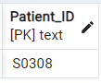



64) seeing the info of the patient in Diabetic group without diabetic_duration

SELECT * FROM public.patient_info WHERE "Patient_ID"='S0308'





65)Create a pie chart to show BADS assessment score categories

SELECT COUNT(*),

CASE WHEN mc."BADS" <11 THEN 'IMPAIRED'

WHEN mc."BADS" BETWEEN 12 AND 13 THEN 'BORDERLINE'

WHEN mc."BADS" BETWEEN 14 AND 15 THEN 'LOW AVERAGE'

WHEN mc."BADS" BETWEEN 16 AND 20 THEN 'AVERAGE'

WHEN mc."BADS" BETWEEN 21 AND 22 THEN 'HIGH AVERAGE'

WHEN mc."BADS" BETWEEN 23 AND 24 THEN 'SUPERIOR'

END AS "BADS CATEGORY"

FROM public."Memory_Cognitive" mc,public."Patients" p,public."Link_Reference" lr

WHERE lr."MC_ID"=mc."MC_ID" AND lr."Link_Reference_ID"=p."Link_Reference_ID"

GROUP BY "BADS CATEGORY"

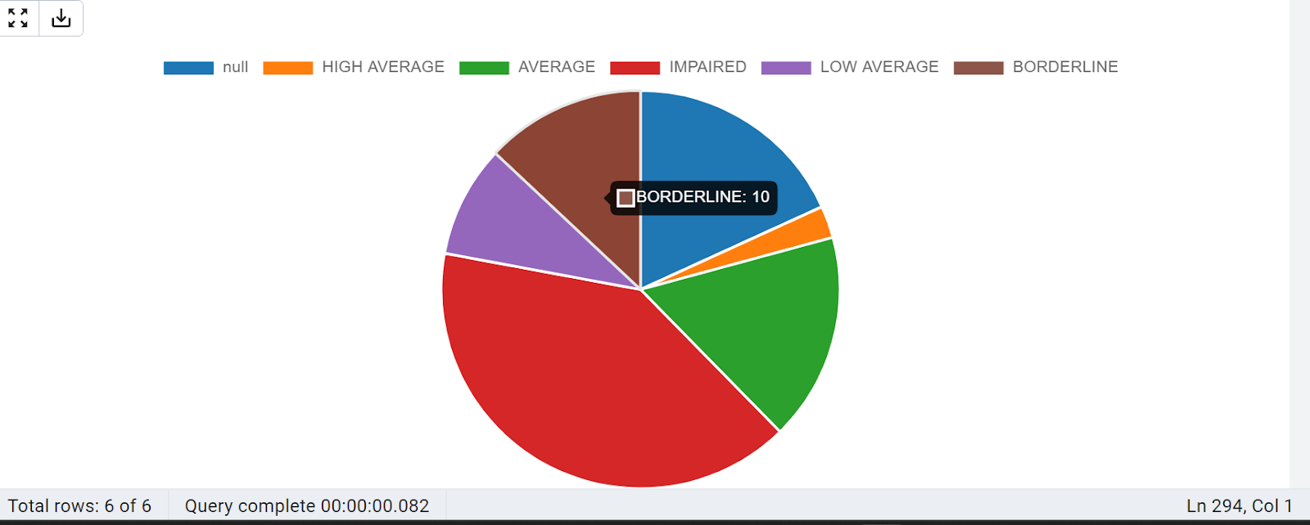

66) Write a query to find number of male and female patients who have less than average BADS score

SELECT g."Gender",COUNT(*) As "UNDER AVERAGE BADS SCORE" FROM public."Memory_Cognitive" mc,"Gender" g, public."Patients" p,public."Link_Reference" lr

WHERE p."Link_Reference_ID"=lr."Link_Reference_ID"

AND lr."MC_ID"=mc."MC_ID"

AND g."Gender_ID"=p."Gender_ID"

AND mc."BADS"<16

GROUP BY g."Gender"

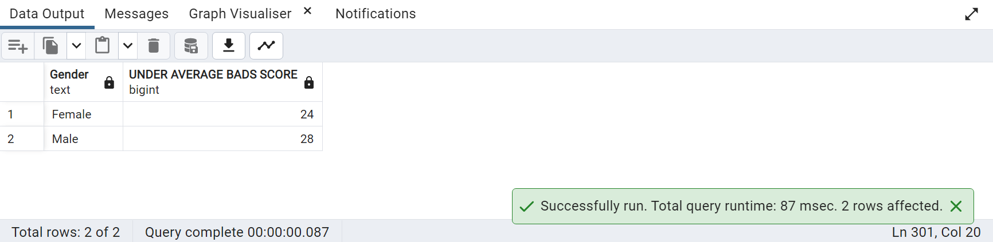

67)Find number of patients who are Impaired Dementially/Cognitively based on GDS score

SELECT COUNT(*) As "Demential/Cognitive Impaired Patients" FROM

public."Memory_Cognitive" mc,public."Patients" p,public."Link_Reference" lr

WHERE lr."MC_ID"=mc."MC_ID" AND lr."Link_Reference_ID"=p."Link_Reference_ID"

AND mc."GDS">=15

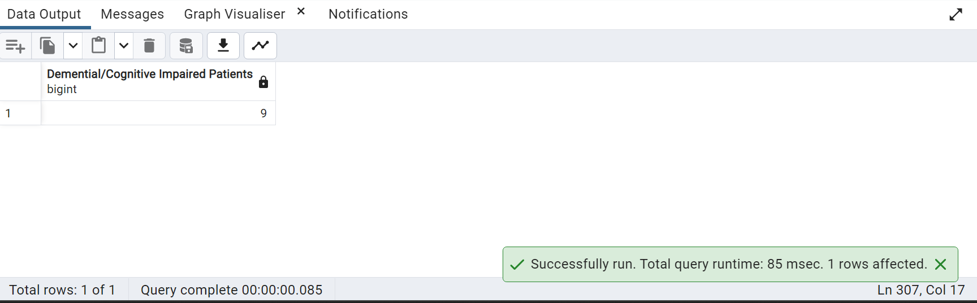

68. write a query to get only the Patients visit time without using Extract function?

SELECT SUBSTRING(TO_CHAR("Visit_Date",'YYYY-MM-DD HH24:MI:SS') from 12 for 8) AS visit_time

FROM public."Patients"

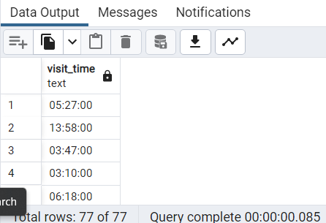

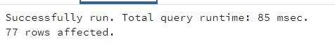

69. List patients whose age is odd

SELECT concat(pt."Firstname"||' '||pt."Lastname") Fullname,pt."Age"

FROM "Patients" pt

WHERE mod("Age",2) <> 0;

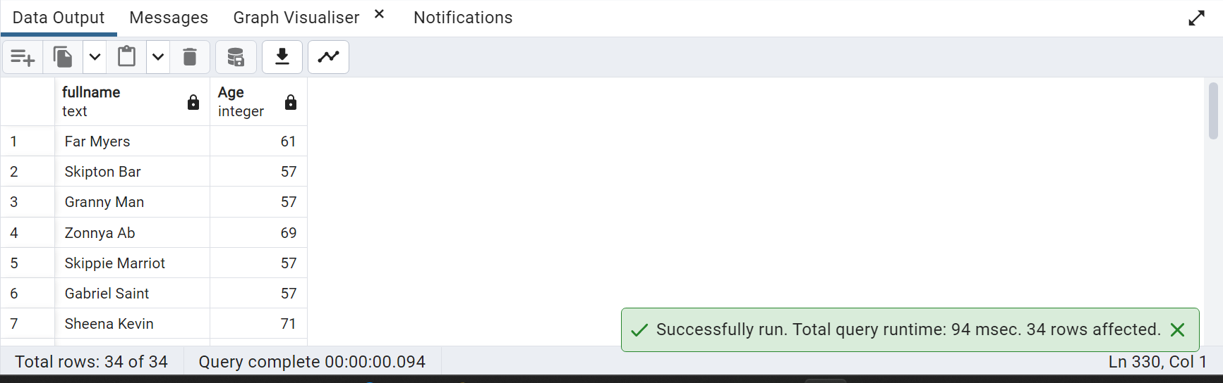

List patients whose age is even

SELECT concat(pt."Firstname"||' '||pt."Lastname") Fullname,pt."Age"

FROM "Patients" pt

WHERE mod("Age",2) = 0;

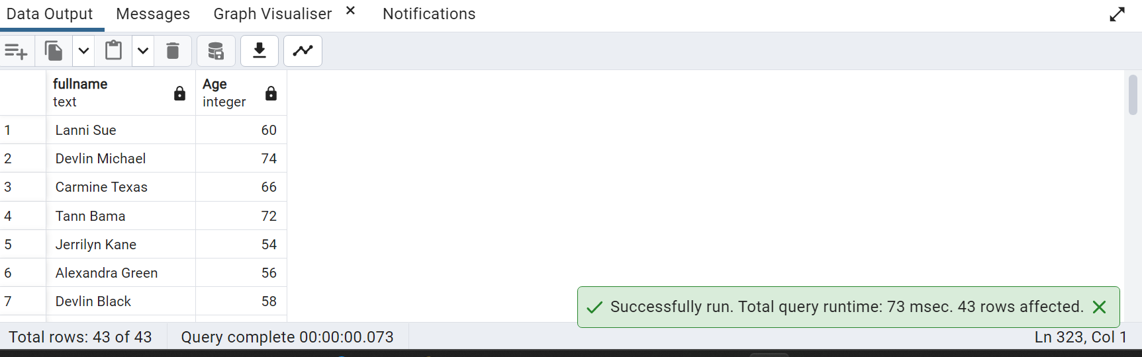

70. Write a query to find patients who have abnormal Creatinine values

SELECT COUNT(*),

CASE WHEN ut."Creatinine" NOT BETWEEN 65.4 AND 119.3 AND g."Gender"='Male' THEN 'Abnormal Creatinine'

WHEN ut."Creatinine" NOT BETWEEN 52.2 AND 91.9 AND g."Gender"='Female' THEN 'Abnormal Creatinine'

ELSE 'Normal'

END As "Creatinine Level"

FROM public."Urine_Test" ut,public."Gender" g,public."Link_Reference" lr,public."Patients" p

WHERE p."Link_Reference_ID"=lr."Link_Reference_ID" AND lr."Urine_ID"=ut."Urine_ID"

AND p."Gender_ID"=g."Gender_ID" AND ut."Creatinine" IS NOT NULL

GROUP BY "Creatinine Level"

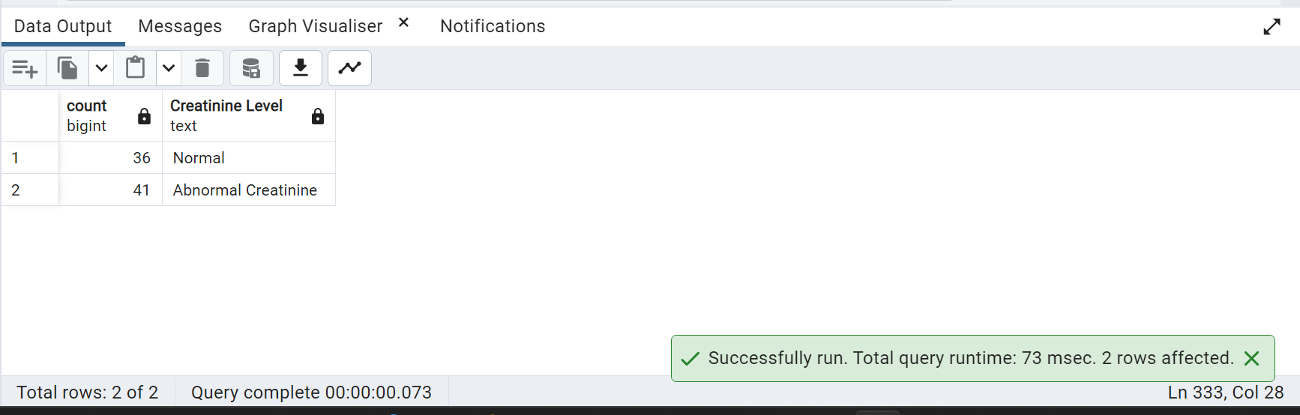

71. Create a pie chart for patients with normal and abnormal Albumin levels

SELECT COUNT(*),

CASE WHEN ut."Albumin"<30 THEN 'Normal Albumin'

ELSE 'Abnormal Albumin'

END As "Albumin Level"

FROM public."Urine_Test" ut,public."Gender" g,public."Link_Reference" lr,public."Patients" p

WHERE p."Link_Reference_ID"=lr."Link_Reference_ID" AND lr."Urine_ID"=ut."Urine_ID"

AND p."Gender_ID"=g."Gender_ID" AND ut."Creatinine" IS NOT NULL

GROUP BY "Albumin Level"

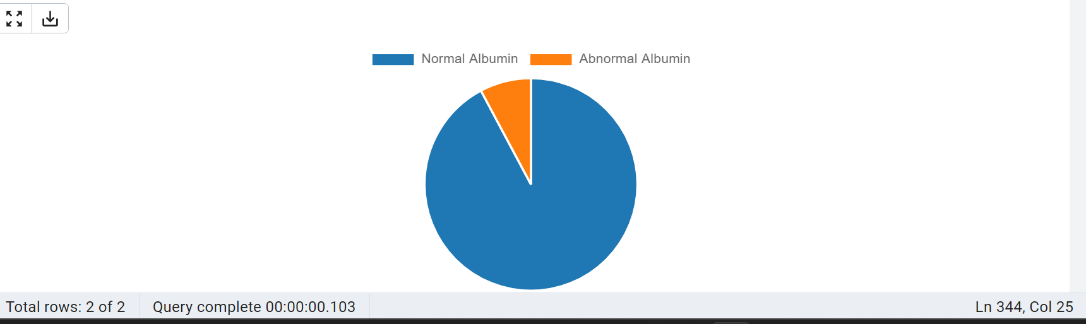

72. Write a explain query

EXPLAIN SELECT * FROM "Patients" WHERE "Age" = '61';

– The EXPLAIN command allows you to view the execution plan for a query

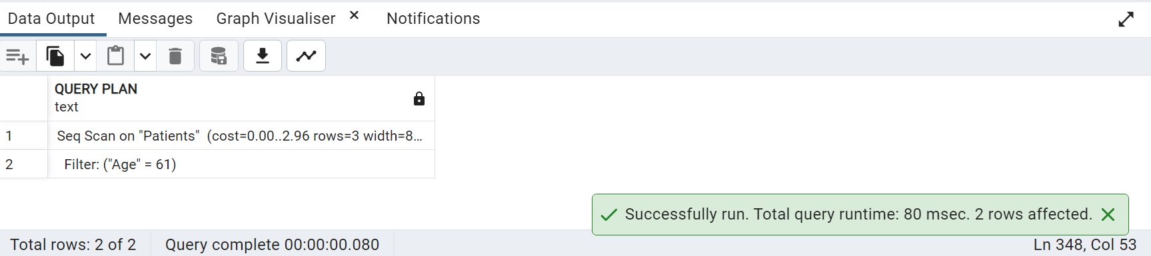

73. Find dementia patients based on HVLT Score

SELECT COUNT(*)As "Patient Count",

CASE WHEN vc."HVLT" <14 THEN 'DEMENTIA'

WHEN vc."HVLT" BETWEEN 14 AND 19 THEN 'MILD DEMENTIA'

ELSE 'NORMAL' END AS "Dementia level"

FROM public."Verbal_Cognitive" vc,public."Link_Reference" lr,public."Patients" p

WHERE vc."VC_ID"=lr."VC_ID"

AND vc."Patient_ID"=p."Patient_ID"

GROUP BY "Dementia level"

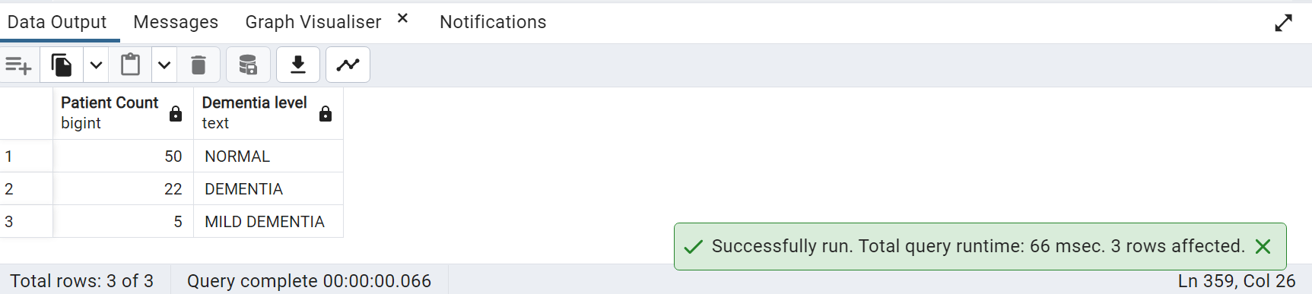

74. Categorizing the insulin levels

SELECT

CASE

WHEN LT."Insulin" < 2.6 THEN 'Low Insulin'

WHEN LT."Insulin" >= 2.6 AND LT."Insulin" <= 24.9 THEN 'Normal Insulin'

WHEN LT."Insulin" > 24.9 THEN 'High Insulin'

END AS "Insulin_Level",

COUNT(*) AS "Patient_Count"

FROM public."Lab_Test" LT

GROUP BY "Insulin_Level";

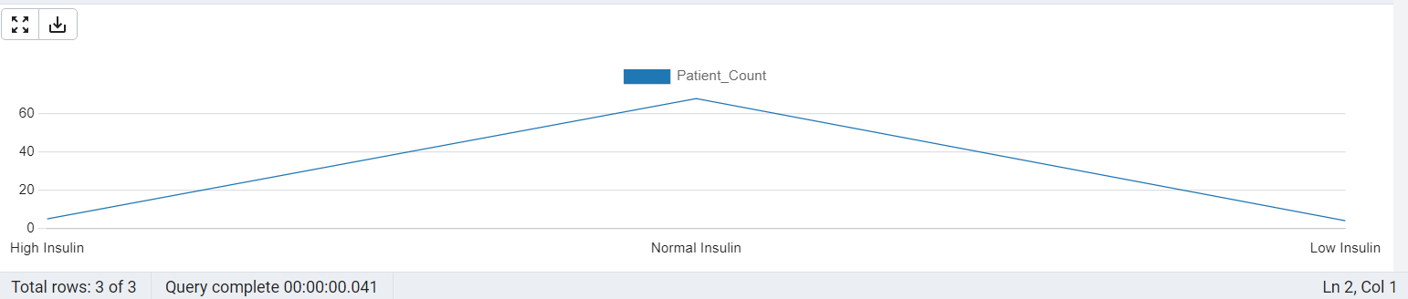

75) Calculate Weight

SELECT "Height", "BMI", ROUND(("BMI" * ("Height" * "Height"))::numeric, 2) AS "Weight"

FROM public."Patients";

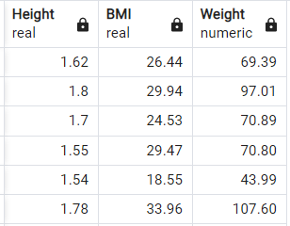



76) Conclusions on BMI and fasting cholesterol levels and categorize them into ranges

SELECT

P."Patient_ID",

P."BMI",

LT."Fasting_Cholestrol",

CASE

WHEN P."BMI" < 18.5 THEN 'Underweight'

WHEN P."BMI" >= 18.5 AND P."BMI" < 25 THEN 'Normal'

WHEN P."BMI" >= 25 AND P."BMI" < 30 THEN 'Overweight'

WHEN P."BMI" >= 30 THEN 'Obese'

END AS "BMI_Category",

CASE

WHEN LT."Fasting_Cholestrol" < 200 THEN 'Desirable'

WHEN LT."Fasting_Cholestrol" >= 200 AND LT."Fasting_Cholestrol" < 240 THEN 'Borderline'

WHEN LT."Fasting_Cholestrol" >= 240 THEN 'High Risk'

END AS "Cholesterol_Category"

FROM public."Patients" P

JOIN public."Lipid_Lab_Test" LT ON P."Patient_ID" = LT."Patient_ID"

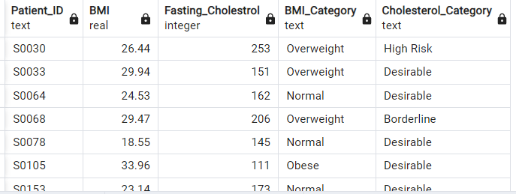



77) Conclusions on BMI and fasting cholesterol levels and categorize them into ranges.Stacked Line Chart

SELECT

P."Patient_ID",

P."BMI",

LT."Fasting_Cholestrol",

CASE

WHEN P."BMI" < 18.5 THEN 'Underweight'

WHEN P."BMI" >= 18.5 AND P."BMI" < 25 THEN 'Normal'

WHEN P."BMI" >= 25 AND P."BMI" < 30 THEN 'Overweight'

WHEN P."BMI" >= 30 THEN 'Obese'

END AS "BMI_Category",

CASE

WHEN LT."Fasting_Cholestrol" < 200 THEN 'Desirable'

WHEN LT."Fasting_Cholestrol" >= 200 AND LT."Fasting_Cholestrol" < 240 THEN 'Borderline'

WHEN LT."Fasting_Cholestrol" >= 240 THEN 'High Risk'

END AS "Cholesterol_Category"

FROM public."Patients" P

JOIN public."Lipid_Lab_Test" LT ON P."Patient_ID" = LT."Patient_ID"

ORDER BY "BMI_Category";

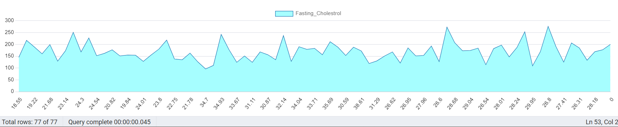

78) Convert height into feet

SELECT

"Patient_ID",

"Height",

CONCAT(

FLOOR("Height" * 3.28084),

'''',

FLOOR((("Height" * 3.28084) - FLOOR("Height" * 3.28084)) * 12),

'"'

) AS "Height_in_Feet"

FROM public."Patients";

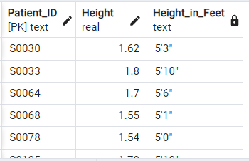



79) Count of Distinct Labs in Lab_Visit

SELECT COUNT(DISTINCT "Lab_names")

FROM public."Lab_Visit"

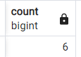



80) COUNT DISTINCT RACE

SELECT COUNT (DISTINCT "Race")

FROM public."Race"

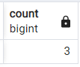



81) COUNT DISTINCT PATIENTS FIRSTNAME

SELECT COUNT (DISTINCT "Firstname")

FROM public."Patients"

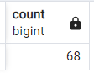



82) REPEATED FIRST NAMES IN PATIENTS TABLE

SELECT "Patient_ID", "Firstname"

FROM public."Patients"

WHERE "Firstname" IN (

SELECT "Firstname"

FROM public."Patients"

GROUP BY "Firstname"

HAVING COUNT(*) > 1);

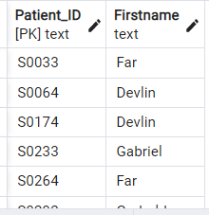



83) Display number of occurrences of each distinct value in the "Clock" line chart

SELECT COUNT ("Patient_ID")

FROM public."Visual/Motor_Cog"

GROUP BY "Clock"

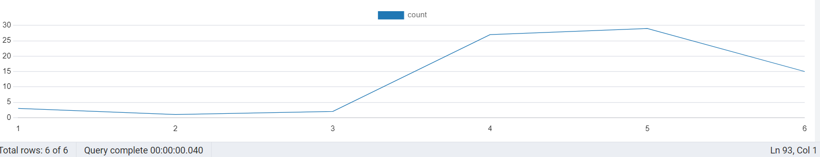

84) REPEATED LAST NAMES IN PATIENTS TABLE

SELECT COUNT (DISTINCT "Lastname")

FROM public."Patients"

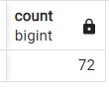



85) concat first name , last name into full name and displayed in all upper

SELECT "Patient_ID", UPPER(CONCAT("Firstname", ' ', "Lastname")) AS "Full_Name"

FROM public."Patients";

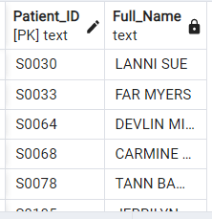



86)Capitalize each word in lab names

SELECT DISTINCT( INITCAP("Lab_names")) AS formatted_lab_name

FROM public."Lab_Visit"

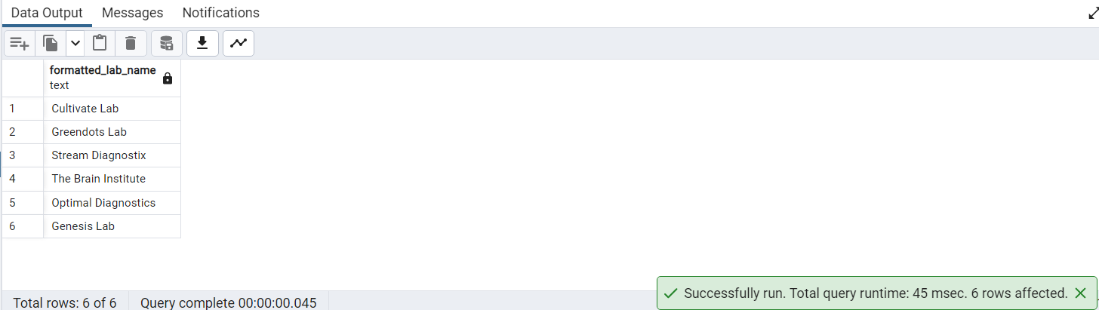

87) Calculate Gait Distance per min

SELECT "Patient_ID",ROUND(("Gait_DT_Distance"::numeric / 6), 2) AS "Gait_DT_Distance_Per_Minute"

FROM public."Walking_Test";

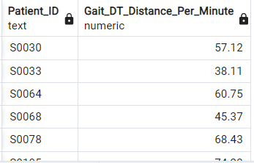



88) number of occurrences of each distinct value in the "Clock"

SELECT COUNT ("Patient_ID")

FROM public."Visual/Motor_Cog"

GROUP BY "Clock"

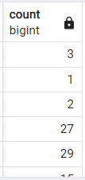



89. Find the count of Dementia patients using TM(Trail Making Test) values

SELECT COUNT(*)As "Patients with Dementia/Cognitive Impairment"

FROM public."Visual/Motor_Cog"

WHERE "TM">=42;

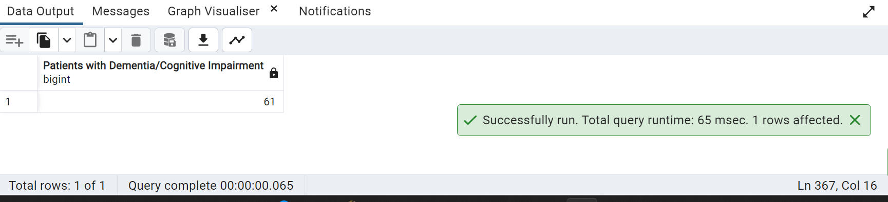

90) List columns of patients table’s with their ordinal position in the table

SELECT column_name,ordinal_position

FROM information_schema.columns

WHERE table_name = 'Patients'

ORDER BY ordinal_position;

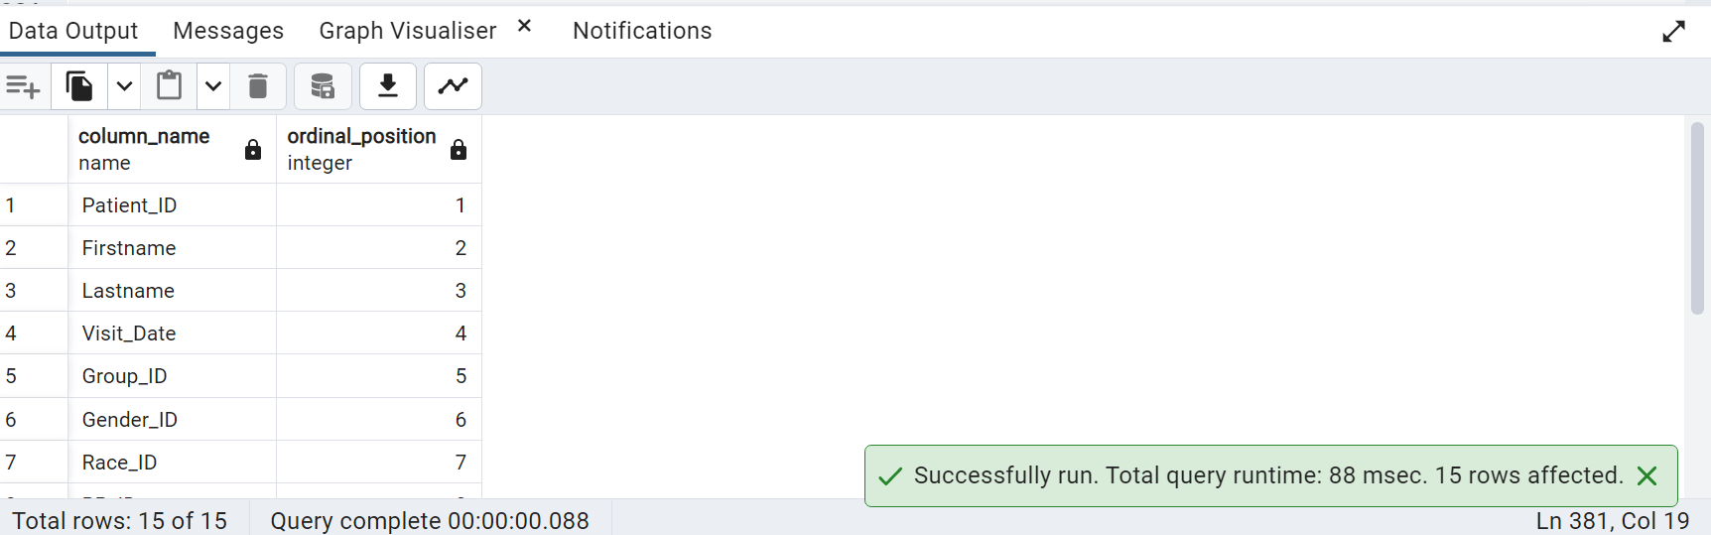

91) Get the top 5 patients with the highest fasting glucose levels

SELECT CONCAT(p."Firstname",' ',p."Lastname")As "Patient Name", lt."Hb_A1C"

FROM public."Patients" p, public."Lab_Test" lt

WHERE p."Patient_ID"=lt."Patient_ID"

AND lt."Hb_A1C" IS NOT NULL

ORDER BY lt."Hb_A1C" DESC

LIMIT 5

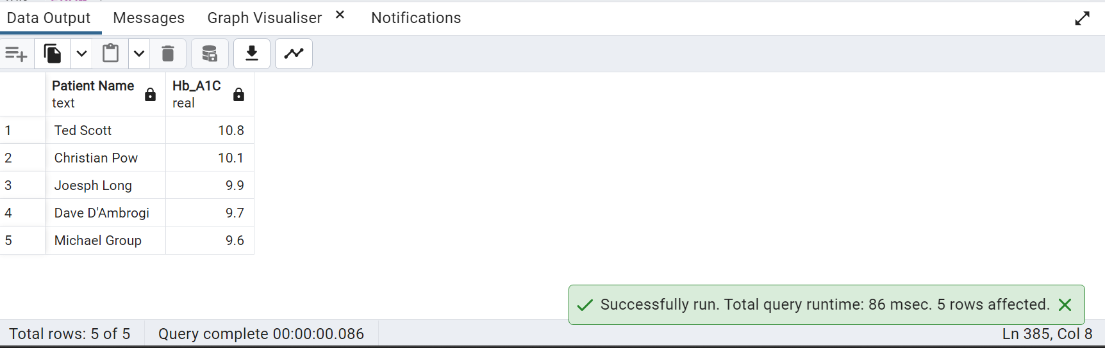

92.write the query to get the patient name who made the last visit to the lab?

SELECT CONCAT (PT."Firstname",' ',PT."Lastname")

FROM PUBLIC."Lab_Visit" LV

JOIN PUBLIC."Link_Reference" LR ON LR."Lab_visit_ID" = LV."Lab_visit_ID"

JOIN public."Patients" PT ON PT."Link_Reference_ID" = LR."Link_Reference_ID"

ORDER BY "Lab_Visit_Date" DESC LIMIT 1;

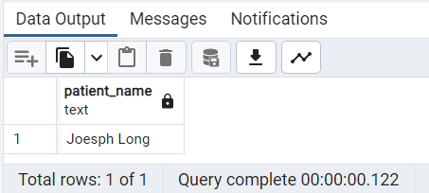

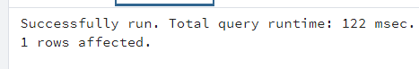

93. Calculate the average BMI (Body Mass Index) for diabetic and non-diabetic patients

SELECT gp."Group",ROUND(AVG(p."BMI")::numeric,2) As "Average BMI" FROM public."Patients" p,public."Group" gp

WHERE p."Group_ID"=gp."Group_ID"

GROUP BY gp."Group"

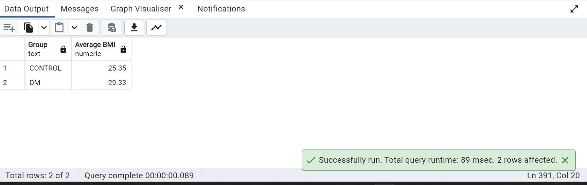

94) Get the patients who have undergone an ophthalmology exam and have both diabetic retinopathy and macular edema:

SELECT CONCAT(p."Firstname",' ',p."Lastname")As "Patients Having Diabetic Retinopathy and Macular Edema"

FROM public."Patients" p

JOIN public."Opthalmology" op ON op."Opthal_ID"=p."Opthal_ID"

WHERE "Diabetic_Retinopathy" >0 AND "Macular_Edema">0;

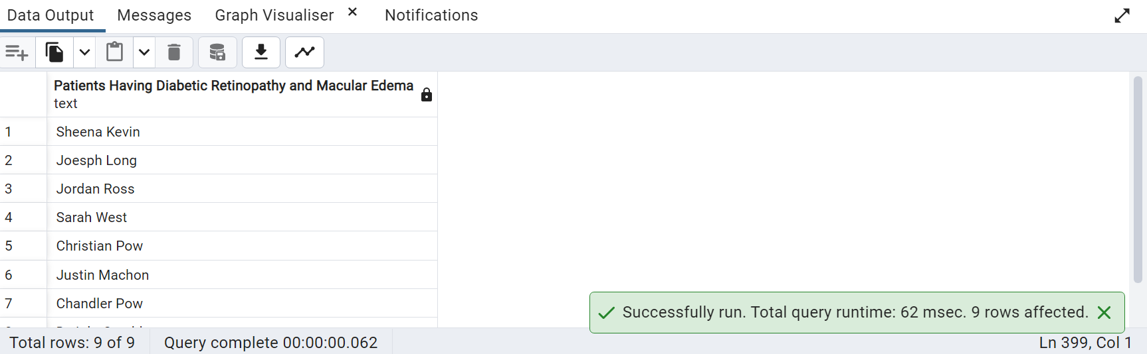

95)Calculate the average LDL cholesterol level for male and female patients:

SELECT ROUND(AVG(llt."Fasting_LDL")::numeric,2),g."Gender"

FROM public."Lipid_Lab_Test" llt

JOIN public."Patients" p ON p."Patient_ID"=llt."Patient_ID"

JOIN public."Gender" g ON g."Gender_ID"=p."Gender_ID"

GROUP BY g."Gender";

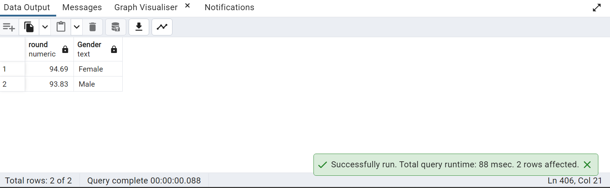

96) Categorize patients based on LDL levels

SELECT

CASE WHEN "Fasting_LDL" < 100 THEN 'Optimal'

WHEN "Fasting_LDL" BETWEEN 101 AND 129 THEN 'Near Optimal'

WHEN "Fasting_LDL" BETWEEN 130 AND 159 THEN 'Borderline High'

WHEN "Fasting_LDL" BETWEEN 160 AND 189 THEN 'High'

ELSE 'Very High'

END AS "LDL Levels",COUNT(*) As "Patient Count"

FROM public."Lipid_Lab_Test"

GROUP BY "LDL Levels";

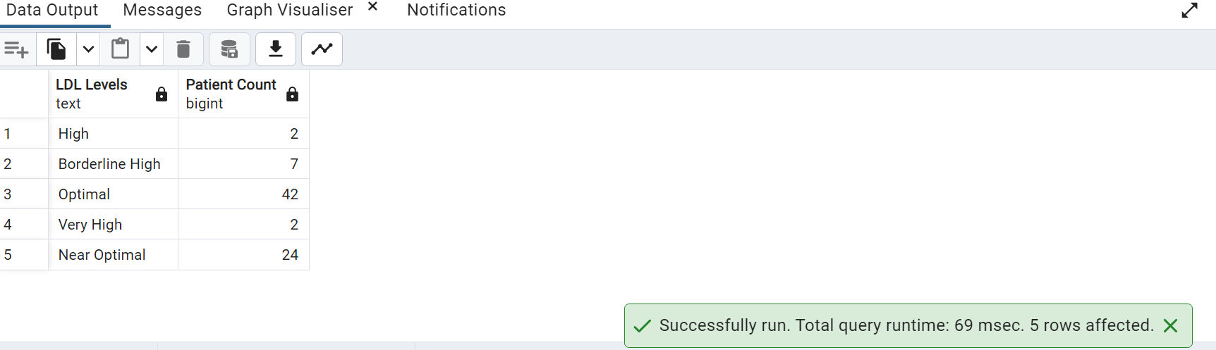

97.) Visually show the patients in Fasting Triglyceride categories as Pie chart

SELECT

CASE WHEN "Fasting_Triglyc"< 150 THEN 'Normal'

WHEN "Fasting_Triglyc" BETWEEN 150 AND 199 THEN 'Borderline'

WHEN "Fasting_Triglyc" BETWEEN 200 AND 499 THEN 'High'

ELSE 'Very High'

END AS "Triglyc Levels",COUNT(*) As "Patient Count"

FROM public."Lipid_Lab_Test"

GROUP BY "Triglyc Levels";

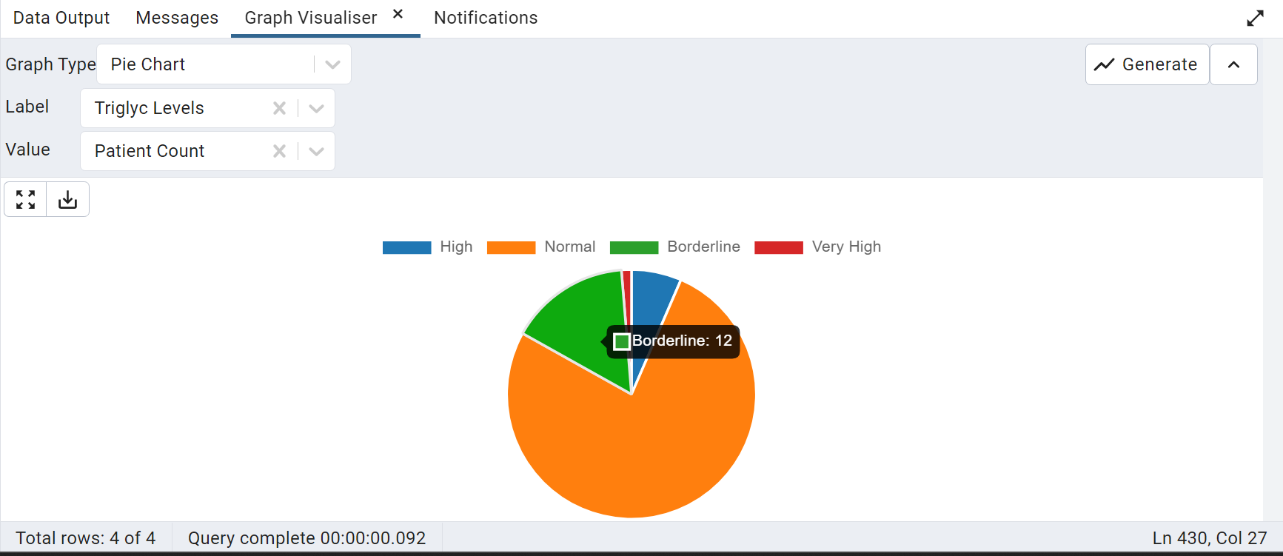

98) Calculate number of male and female patients at risk of heart disease

SELECT COUNT(*) As "Male Patients at risk of heart disease" FROM public."Gender" g

JOIN public."Patients" p ON p."Gender_ID" = g."Gender_ID"

JOIN public."Lipid_Lab_Test" llt ON llt."Patient_ID"=p."Patient_ID"

WHERE g."Gender"='Male' AND llt."Fasting_HDL" >40;

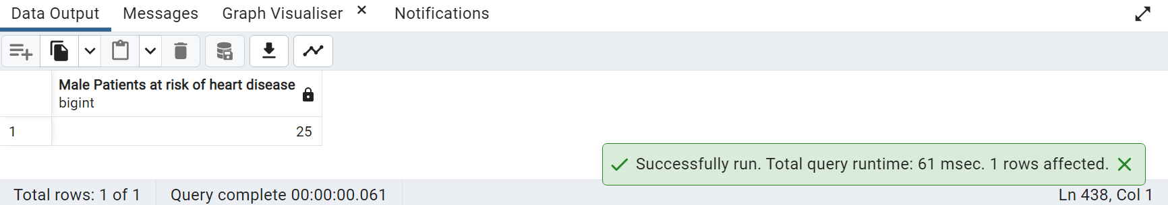

99)Get the datatype of a specific field from the Patient table.

SELECT column_name, data_type FROM information_schema.columns WHERE

table_name = 'Patients' AND column_name = 'Firstname';

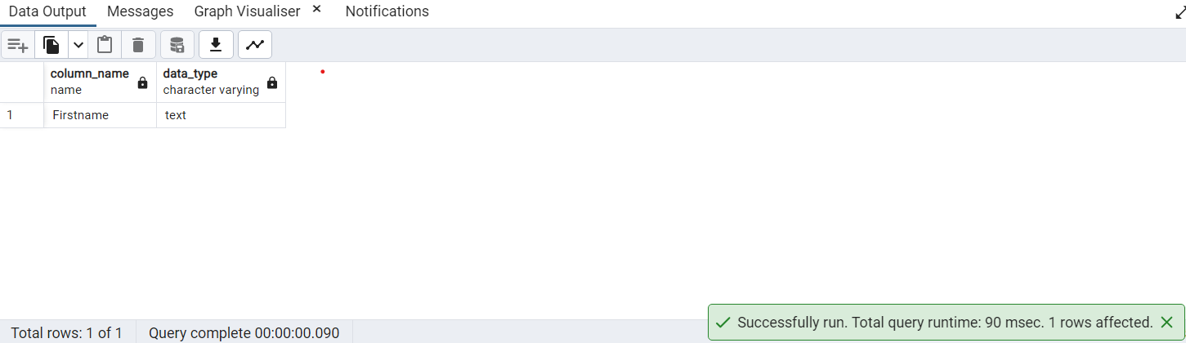

100) Find patients with Abnormal Hemoglobin level

SELECT COUNT(*),

CASE WHEN g."Gender"='Male' AND lt."Hgb" BETWEEN 13.2 AND 16.6 THEN 'Normal'

WHEN g."Gender"='Female' AND lt."Hgb" BETWEEN 11.5 AND 15 THEN 'Normal'

ELSE 'Abnormal' END As "Hemoglobin Level"

FROM public."Lab_Test" lt,public."Gender" g,public."Patients" p

WHERE p."Patient_ID"=lt."Patient_ID"

AND p."Gender_ID"=g."Gender_ID"

GROUP BY "Hemoglobin Level";

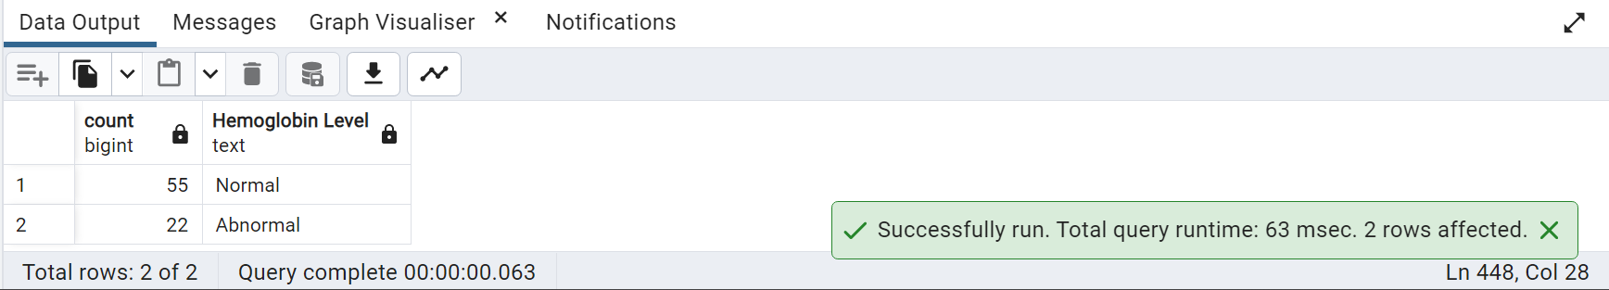

101) Give all the numbers in denormalized form by patients wise. PATIENT RECORDS.

SELECT

P."Patient_ID",

CONCAT(P."Firstname", ' ', P."Lastname") AS "Full_Name",

P."Age",

P."BMI",

G."Gender",

R."Race",

BP."24Hr_Day_SBP",

BP."24Hr_Day_DBP",

BP."24Hr_Day_HR",

LT."Fasting_Glucose",

LLT."Fasting_Cholestrol",

O."Macular_Edema",

MC."GDS",

VMC."Clock",

UT."Albumin",

VC."DS",

WT."Gait_DT_Distance"

FROM public."Patients" P

JOIN public."Gender" G ON G."Gender_ID" = P."Gender_ID"

JOIN public."Race" R ON R."Race_ID" = P."Race_ID"

JOIN public."Group" GR ON GR."Group_ID" = P."Group_ID"

JOIN public."Blood_Pressure" BP ON BP."BP_ID" = P."BP_ID"

JOIN public."Lab_Test" LT ON LT."Patient_ID" = P."Patient_ID"

JOIN public."Lipid_Lab_Test" LLT ON LLT."Patient_ID" = P."Patient_ID"

JOIN public."Opthalmology" O ON O."Opthal_ID" = P."Opthal_ID"

JOIN public."Link_Reference" LR ON LR."Link_Reference_ID" = P."Link_Reference_ID"

JOIN public."Memory_Cognitive" MC ON MC."MC_ID" = LR."MC_ID"

JOIN public."Visual/Motor_Cog" VMC ON VMC."Patient_ID" = P."Patient_ID"

JOIN public."Urine_Test" UT ON UT."Urine_ID" = LR."Urine_ID"

JOIN public."Verbal_Cognitive" VC ON VC."Patient_ID" = P."Patient_ID"

JOIN public."Walking_Test" WT ON WT."Patient_ID" = P."Patient_ID";

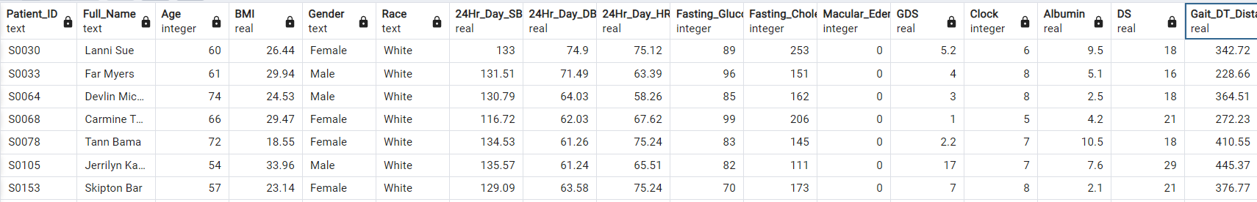



102)How many tables is patients table linked to

SELECT COUNT(DISTINCT "table_name") AS "Linked_Tables_Count"

FROM information_schema.constraint_column_usage

WHERE constraint_name IN (

SELECT constraint_name

FROM information_schema.table_constraints

WHERE table_name = 'Patients' AND table_schema = 'public'

)

AND table_schema = 'public' AND table_name <> 'Patients';

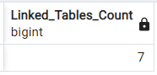



103)Find number of Patients with Thrombocytopenia by race and Gender

SELECT COUNT(P."Patient_ID") AS "Thrombocytopenia_Count", G."Gender", R."Race"

FROM public."Patients" P

JOIN public."Gender" G ON G."Gender_ID" = P."Gender_ID"

JOIN public."Race" R ON R."Race_ID" = P."Race_ID"

JOIN public."Lab_Test" LT ON LT."Patient_ID" = P."Patient_ID"

WHERE LT."Platelets" < 150

GROUP BY G."Gender", R."Race";

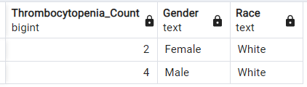



104) Find number of patients with High Diabetic levels by race and Gender

SELECT COUNT(P."Patient_ID") AS "Diabetic_Count", G."Gender", R."Race"

FROM public."Patients" P

JOIN public."Gender" G ON G."Gender_ID" = P."Gender_ID"

JOIN public."Race" R ON R."Race_ID" = P."Race_ID"

JOIN public."Lab_Test" LT ON LT."Patient_ID" = P."Patient_ID"

WHERE LT."Fasting_Glucose">120

GROUP BY G."Gender",R."Race"

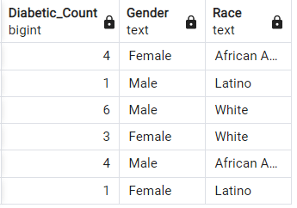



105)Show lab visit dates where there are more than one visit

SELECT TO_CHAR("Lab_Visit_Date", 'YYYY-MM-DD') AS "Date", COUNT("Lab_visit_ID") AS "Visit_Count"

FROM public."Lab_Visit"

GROUP BY TO_CHAR("Lab_Visit_Date", 'YYYY-MM-DD')

HAVING COUNT("Lab_visit_ID") > 1

ORDER BY "Date";

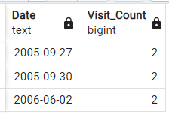



106) Fetch the records of weekly visit reports where the visit is more than 1. line chart

SELECT TO_CHAR(DATE_TRUNC('week', "Lab_Visit_Date"), 'YYYY-"W"IW') AS "Week_Number",

COUNT(DISTINCT "Lab_visit_ID") AS "Visit_Count"

FROM public."Lab_Visit"

GROUP BY TO_CHAR(DATE_TRUNC('week', "Lab_Visit_Date"), 'YYYY-"W"IW')

HAVING COUNT(DISTINCT "Lab_visit_ID") > 1

ORDER BY "Week_Number";

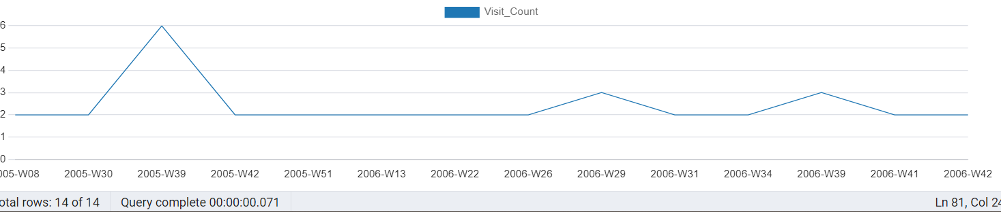

107) collect the lab unique patients records by (lab wise, test wise)

SELECT L."Lab_names",

COUNT(DISTINCT P."Patient_ID") AS "Unique_Patient_Count"

FROM public."Patients" P

JOIN public."Link_Reference" LR ON LR."Link_Reference_ID" = P."Link_Reference_ID"

JOIN public."Lab_Visit" L ON L."Lab_visit_ID" = LR."Lab_visit_ID"

GROUP BY L."Lab_names"

ORDER BY L."Lab_names";

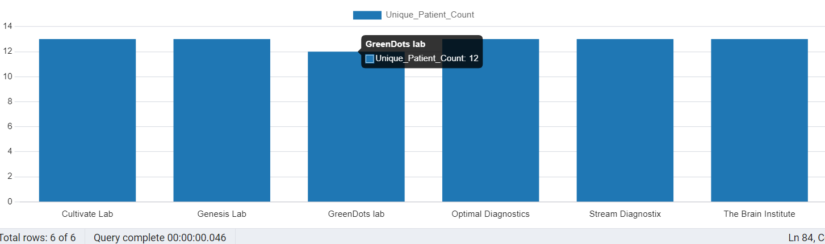

108) Patients count for GDS range from 0-14.9 NORMAL RANGE by race and Gender wise

SELECT COUNT(P."Patient_ID") AS "Patient_Count", R."Race", G."Gender"

FROM public."Patients" P

JOIN public."Race" R ON R."Race_ID" = P."Race_ID"

JOIN public."Gender" G ON G."Gender_ID" = P."Gender_ID"

JOIN public."Link_Reference" LR ON LR."Link_Reference_ID" = P."Link_Reference_ID"

JOIN public."Memory_Cognitive" MC ON MC."MC_ID" = LR."MC_ID"

WHERE MC."GDS" > 0 AND MC."GDS" < 14.9

GROUP BY R."Race", G."Gender";

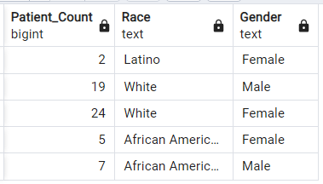



109) Dementia across age groups. line graph

SELECT

FLOOR((P."Age" - 1) / 5) * 5 || '-' || FLOOR((P."Age" - 1) / 5) * 5 + 4 AS "Age_Range",

COUNT(DISTINCT CASE

WHEN MC."IADL" <= 14 THEN P."Patient_ID"

WHEN MC."MMSE" <= 23 THEN P."Patient_ID"

WHEN MC."GDS" >= 15 THEN P."Patient_ID"

WHEN VMC."RCFT_IR" <= 71 THEN P."Patient_ID"

WHEN VMC."TM" >= 42 THEN P."Patient_ID"

WHEN VMC."Clock" <= 2 THEN P."Patient_ID"

WHEN VC."DS" < 13 THEN P."Patient_ID"

WHEN VC."HVLT" < 19 THEN P."Patient_ID"

WHEN VC."VF" < 42 THEN P."Patient_ID"

WHEN VC."WTAR" <= 20 THEN P."Patient_ID"

END) AS "Dementia_Patient_Count"

FROM public."Patients" P

JOIN public."Link_Reference" LR ON LR."Link_Reference_ID" = P."Link_Reference_ID"

JOIN public."Memory_Cognitive" MC ON MC."MC_ID" = LR."MC_ID"

JOIN public."Visual/Motor_Cog" VMC ON VMC."Patient_ID" = P."Patient_ID"

JOIN public."Verbal_Cognitive" VC ON VC."Patient_ID" = P."Patient_ID"

GROUP BY FLOOR((P."Age" - 1) / 5) * 5

ORDER BY FLOOR((P."Age" - 1) / 5) * 5;

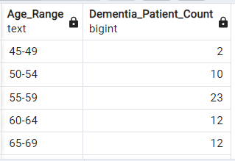



110)Get the list of patients who's Id number has 2.

SELECT "Patient_ID"

FROM public."Patients"

WHERE "Patient_ID" LIKE '%2%'

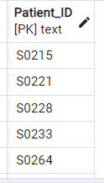



111) STUDY OF PATIENTS WHOSE CHOLESTEROL IS HIGH. RACE WISE AND GENDER WISE

SELECT COUNT(P."Patient_ID") AS "Patient_Count",R."Race",G."Gender"

FROM public."Patients" P

JOIN public."Race" R ON R."Race_ID" = P."Race_ID"

JOIN public."Gender" G ON G."Gender_ID" = P."Gender_ID"

JOIN public."Lipid_Lab_Test" L ON L."Patient_ID" = P."Patient_ID"

WHERE L."Fasting_Cholestrol" > 240

GROUP BY R."Race", G."Gender";

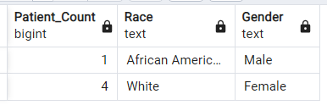



112)Measure the GAIT_DT_Speed age critria is(55)

SELECT P."Age", WT."Patient_ID", WT."Gait_DT_Speed"

FROM public."Walking_Test" WT

JOIN public."Patients" P ON P."WalkTest_ID" = WT."WalkTest_ID"

WHERE P."Age"=55

GROUP BY P."Age", WT."Patient_ID", WT."Gait_DT_Speed";

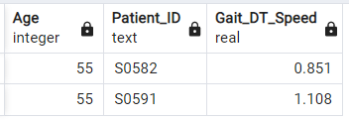



113) AVERAGE GAIT SPEED OVER AGE

SELECT

(WIDTH_BUCKET(P."Age", 0, 100, 20) * 5 - 4) || ' - ' || (WIDTH_BUCKET(P."Age", 0, 100, 20) * 5) AS "Age_Range",

ROUND(AVG(WT."Gait_DT_Speed"::numeric), 2) AS "Average_Speed"

FROM public."Walking_Test" WT

JOIN public."Patients" P ON P."WalkTest_ID" = WT."WalkTest_ID"

GROUP BY WIDTH_BUCKET(P."Age", 0, 100, 20)

ORDER BY "Age_Range";

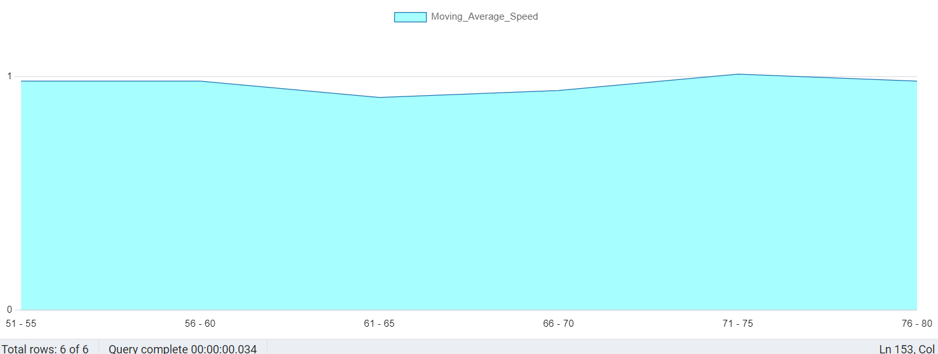

114)Sort patientsID ,height in patients table based on over BMI using Dense rank.

SELECT "Patient_ID","Height","BMI",

DENSE_RANK() OVER (ORDER BY "BMI" DESC) AS bmi_rank

FROM public."Patients";

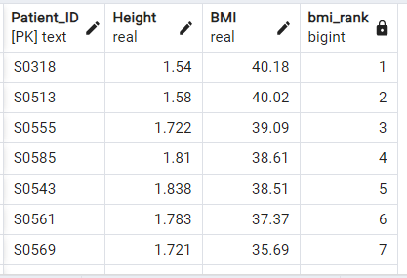



115) Show unique height value, and the ages column contains an array of ages for each height.

SELECT "Height",

ARRAY_AGG("Age") AS ages

FROM public."Patients"

GROUP BY "Height"

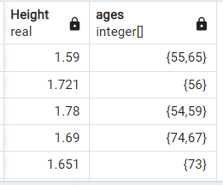



116)USING ARRAY AGGREGATION DISPLAY PATIENTS WHO VISITED LABS ACCORDINGLY

SELECT LV."Lab_names",

ARRAY_AGG(P."Patient_ID") AS PATIENTS

FROM public."Lab_Visit" LV

JOIN public."Link_Reference" LR ON LR."Lab_visit_ID" = LV."Lab_visit_ID"

JOIN public."Patients" P ON P."Link_Reference_ID" = LR."Link_Reference_ID"

GROUP BY LV."Lab_names"

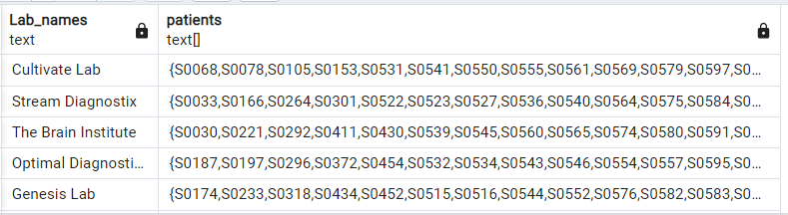



117)WRITE A QUERY TO FIND GET PATIENTSCOUNT OF EACH RACE ,WHO HAVE BOTH DIABETIC _RETINOPATHY AND "Macular_Edema"

SELECT COUNT(R."Race"),R."Race"

FROM public."Patients" P

JOIN public."Opthalmology" OP ON OP."Opthal_ID" = P."Opthal_ID"

JOIN public."Race" R ON R."Race_ID" = P."Race_ID"

WHERE OP."Diabetic_Retinopathy" != 0 AND OP."Macular_Edema" != 0

GROUP BY R."Race" ;

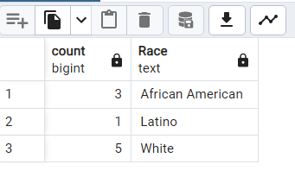

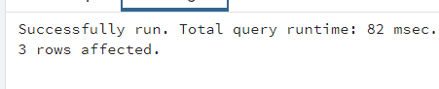

118)WRITE A QUERY TO FIND PATIENT WHO DO NOT HAVE OPTIMAL INSULIN LEVEL .

SELECT CONCAT (PT."Firstname",' ',PT."Lastname") patient_name FROM public."Lab_Test" LT

JOIN public."Patients" PT ON PT."Patient_ID" = LT."Patient_ID"

WHERE "Insulin" NOT BETWEEN 2.6 AND 24.6

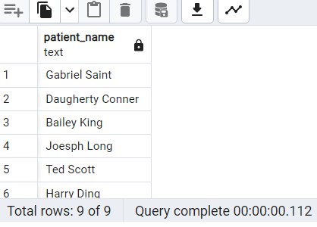

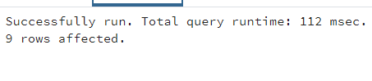

119)WRITE THE PERCENTAGE OF GENDER WHO ARE IN PREDIABETIC STATE.

SELECT GD."Gender",COUNT(*) * 100.0 / SUM(COUNT(*)) OVER () AS percentage

FROM public."Lab_Test" LT

JOIN public."Link_Reference" LR ON LT."Lab_ID" = LR."Lab_ID"

JOIN public."Patients" PT ON PT."Link_Reference_ID" = LR."Link_Reference_ID"

JOIN public."Gender" GD ON PT."Gender_ID" = GD."Gender_ID"

WHERE LT."Hb_A1C" BETWEEN 5.7 AND 6.4 OR LT."Fasting_Glucose" = 100

GROUP BY GD."Gender"

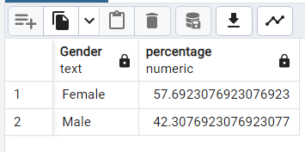

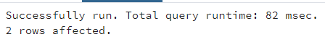

120)WRITE A QUERY TO GET LEAST 3 RECORDS ,WHOSE GAIT_DT_DISTANCE IS MINIMUM ALONG WITH THEIR AGE, GENDER AND RACE

SELECT PT."Age",G."Gender",R."Race"

FROM public."Walking_Test" WT

JOIN public."Patients" PT ON PT."WalkTest_ID" = WT."WalkTest_ID"

JOIN public."Gender" G ON PT."Gender_ID" = G."Gender_ID"

JOIN public."Race" R ON R."Race_ID" = PT."Race_ID"

ORDER BY "Gait_DT_Distance" LIMIT 3;

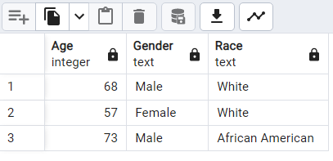

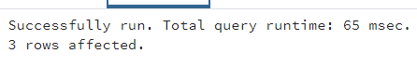

121)WRITE A QUERY TO FIND PATIENTS NAME RACE AND AGE GREATER THAN 55, WHOSE IS HAVING BOTH VERBAL_COGNITIVE AND ALSO HAVE KIDNEY RELATED ISSUES

SELECT CONCAT (PT."Firstname",' ',PT."Lastname") patient_name,R."Race",PT."Age"

FROM public."Verbal_Cognitive" VC

JOIN public."Link_Reference" LR ON LR."VC_ID" = VC."VC_ID"

JOIN public."Urine_Test" UT ON UT."Urine_ID" = LR."Urine_ID"

JOIN public."Patients" PT ON PT."Link_Reference_ID" = LR."Link_Reference_ID"

JOIN public."Race" R ON R."Race_ID" = PT."Race_ID"

WHERE UT."Albumin" NOT BETWEEN 3.4 AND 5.4

AND ("DS" < 13 OR "VF" < 42 OR "WTAR" <= 20 )

AND PT."Age" > 55;

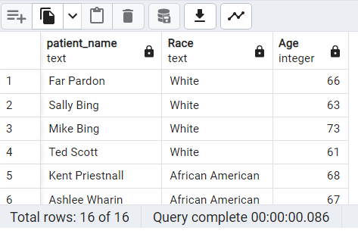

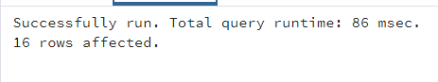

122) Using sub-query show all records whose BMI is above 24.9.

SELECT P."Patient_ID", P."Age", P."BMI"

FROM (SELECT * FROM public."Patients" WHERE "BMI" > 24.9) AS P;

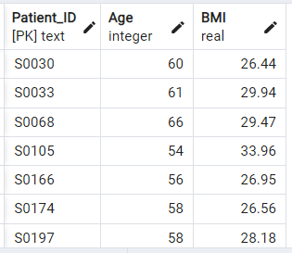



123) Using Nested Queries in SQL find patients id whose "Hb_A1C">6.5

SELECT P."Patient_ID", LT."Hb_A1C"

FROM public."Patients" AS P

JOIN public."Lab_Test" AS LT ON P."Patient_ID" = LT."Patient_ID"

WHERE P."Patient_ID" IN (

SELECT LT."Patient_ID"

FROM public."Lab_Test" AS LT

WHERE LT."Hb_A1C" > 6.5);

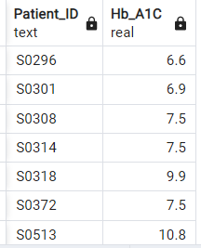



124) Using Correlated Subqueries show patient whose "Insulin" < 2.6.

SELECT P."Patient_ID", LT."Insulin"

FROM public."Patients" AS P

JOIN public."Lab_Test" AS LT ON P."Patient_ID" = LT."Patient_ID"

WHERE LT."Insulin" < 2.6

AND EXISTS (

SELECT 1

FROM public."Lab_Test" AS LT2

WHERE LT2."Patient_ID" = P."Patient_ID" AND LT2."Insulin" < 2.6);

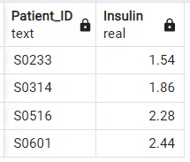

125)USE FULL JOIN TO DISPLAY PATIENTS ID WITH AGE, WTAR, TM

SELECT V."Patient_ID",V."WTAR" , VM."TM", P."Age"

FROM public."Verbal_Cognitive" AS V

FULL JOIN public."Visual/Motor_Cog" AS VM ON VM."Patient_ID" = V."Patient_ID"

FULL JOIN public."Patients" AS P ON P."Patient_ID" = V."Patient_ID";

